**AZURE DEV L2**

Firstly for working on azure, subscribe Microsoft azure.

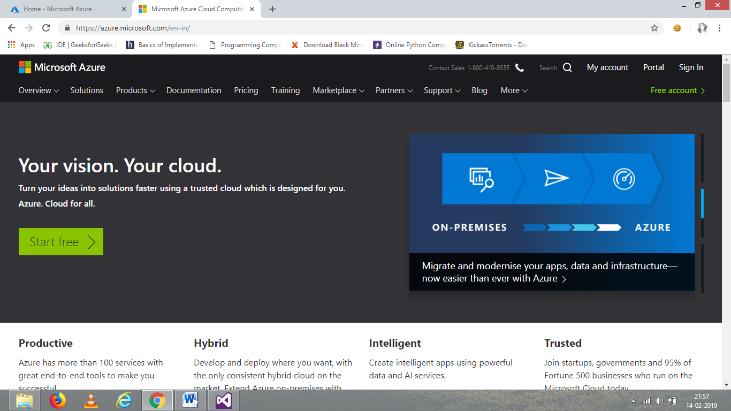

Create an account for access in azure cloud with details required.

After creating account, open portal which is next to my account.

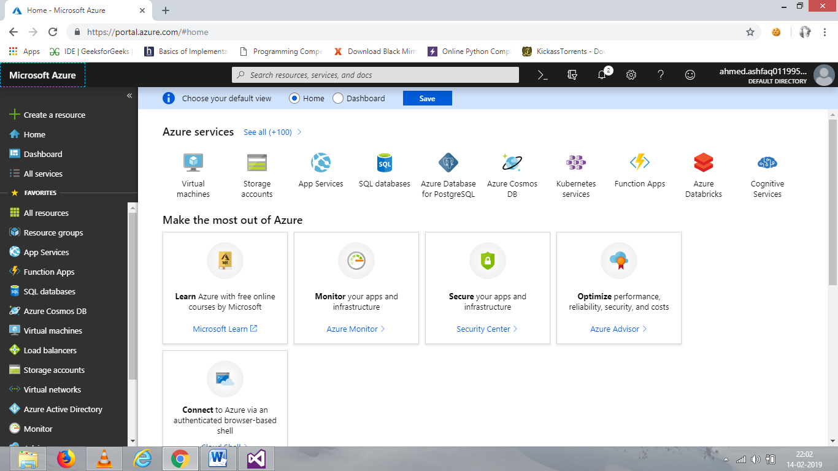

The dashboard of azure will display on the screen.

Below image shows how to connect and use the services provided by azure.

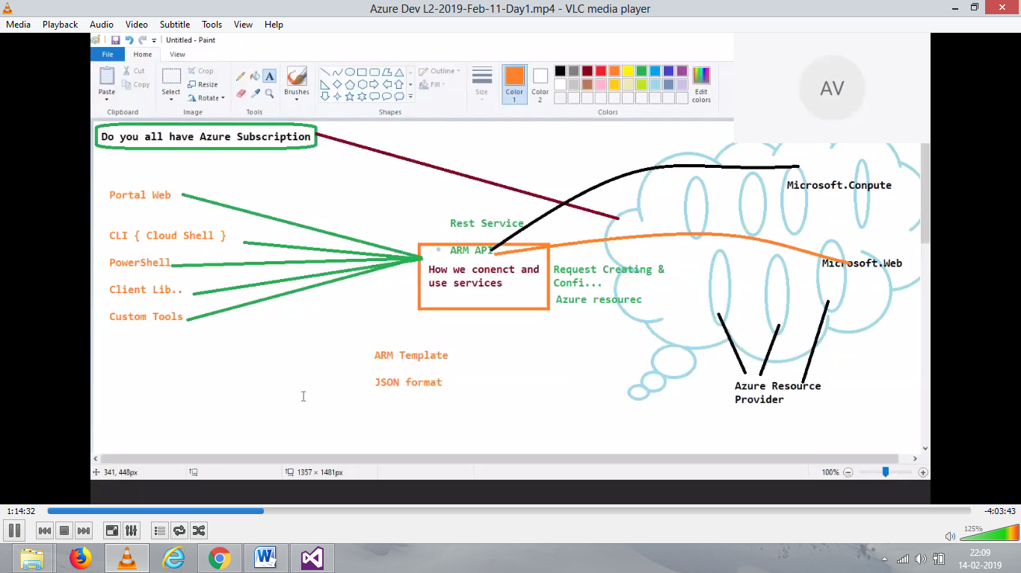

First task is to hosting web application on the azure platform.

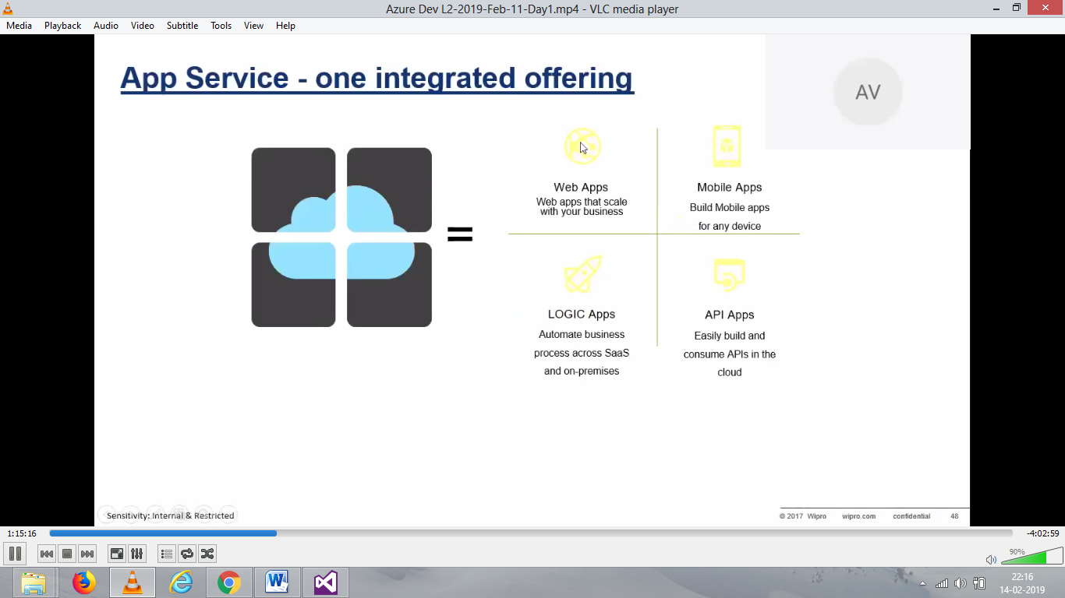

Azure App service provides all above.

For creating a azure web app, first click on create a resource.

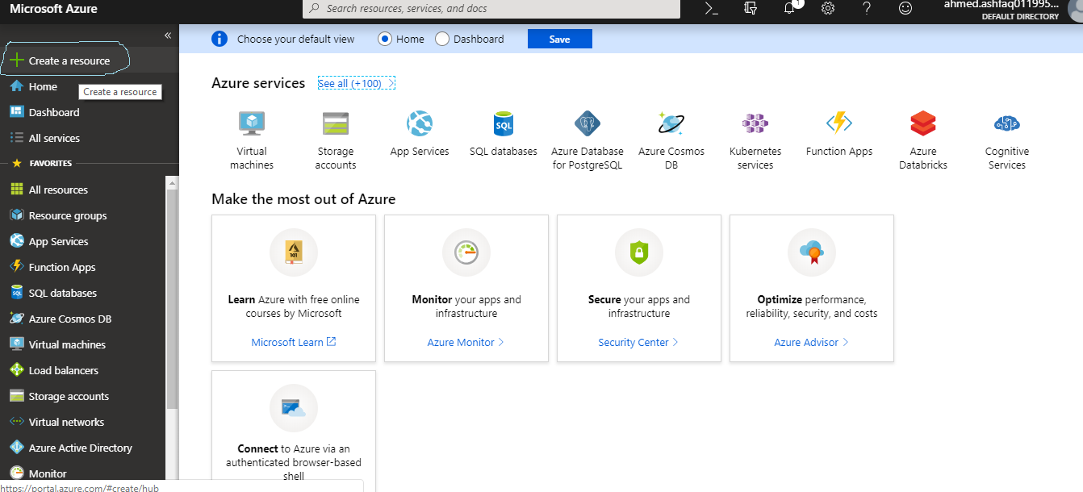

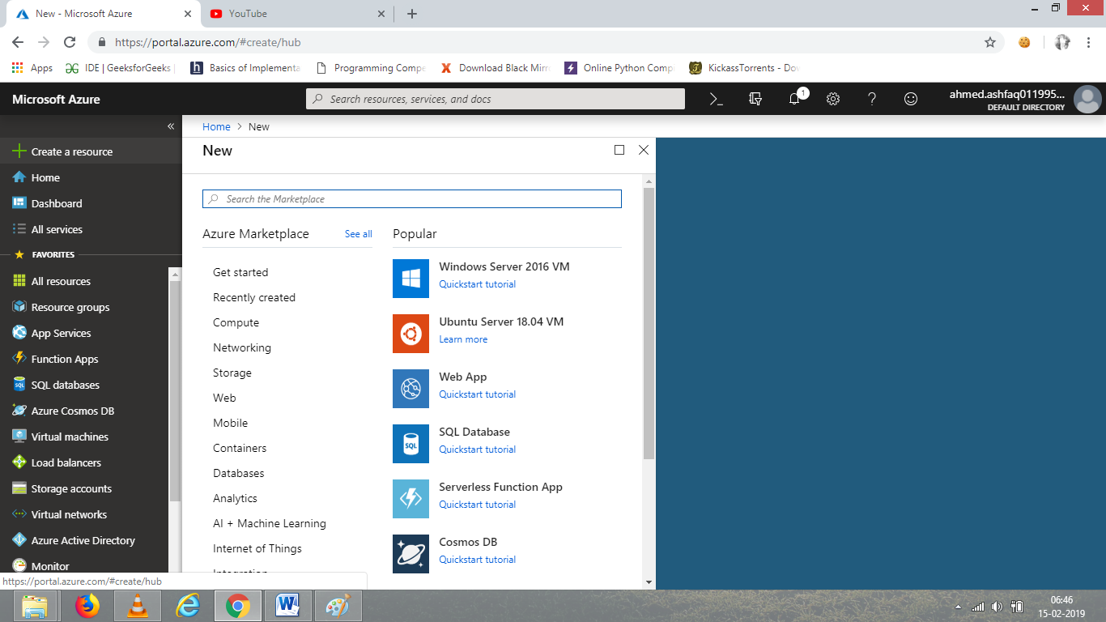

Now click on Web app for creating web app.

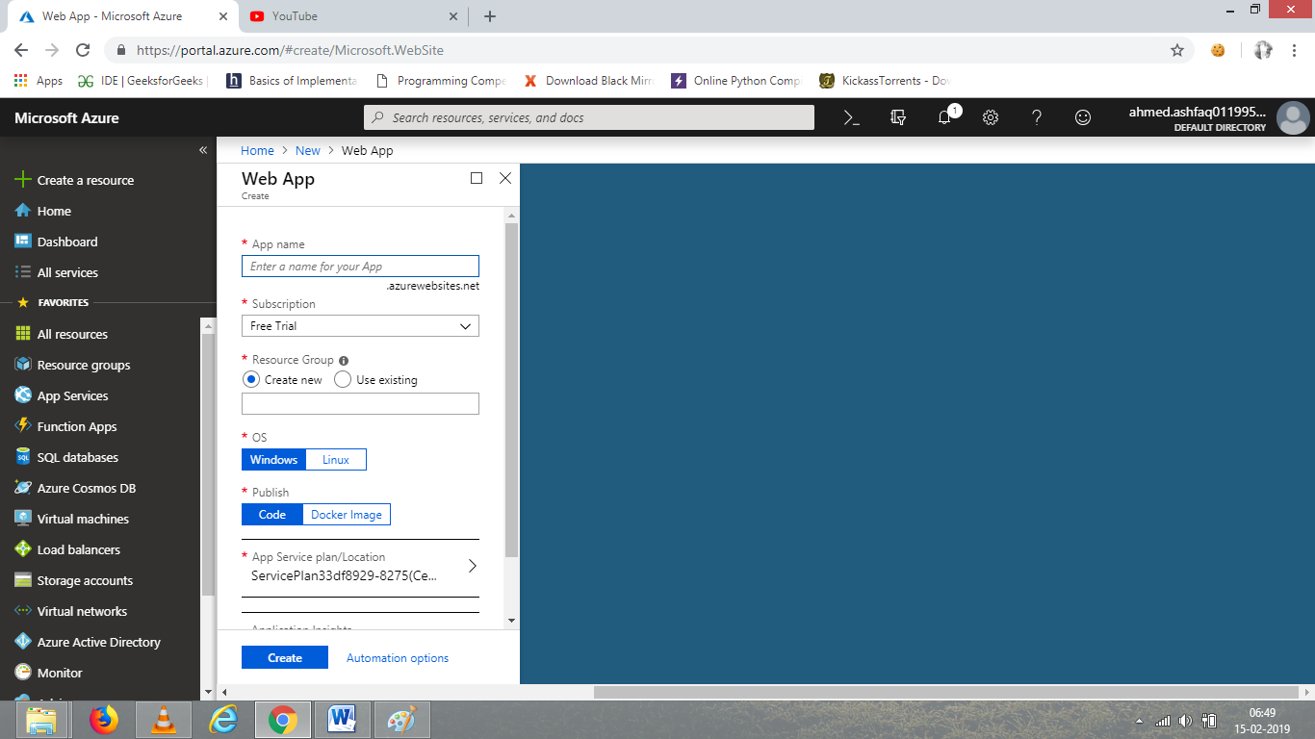

Give a name to App and resource group name.

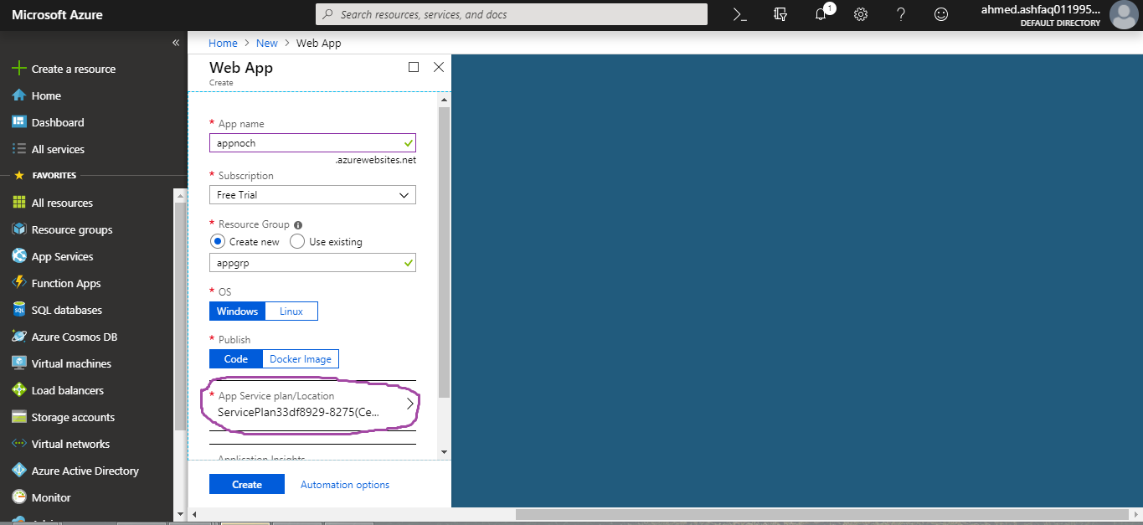

The operating system is windows and publish is code. And then we need app service plan so click on it and create new plan to know about the plan and the cost for the app.

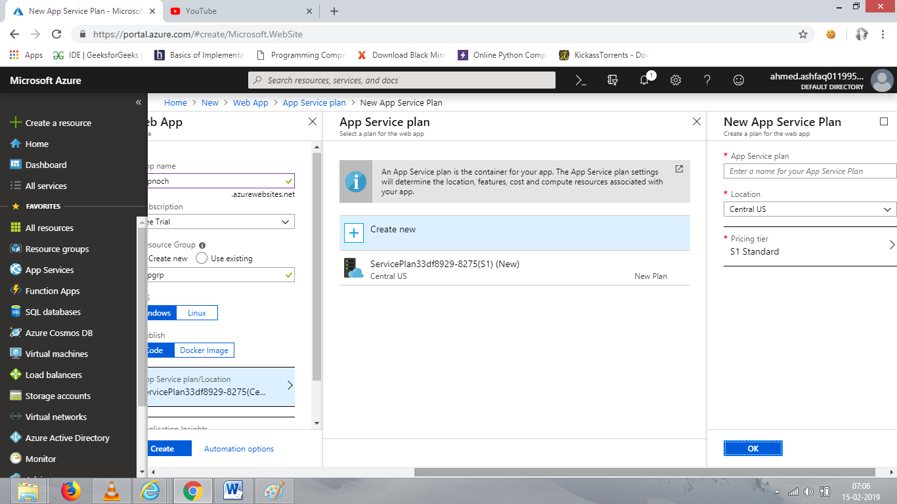

Select S1 standard and location as central India, and enter the name for plan then click ok.

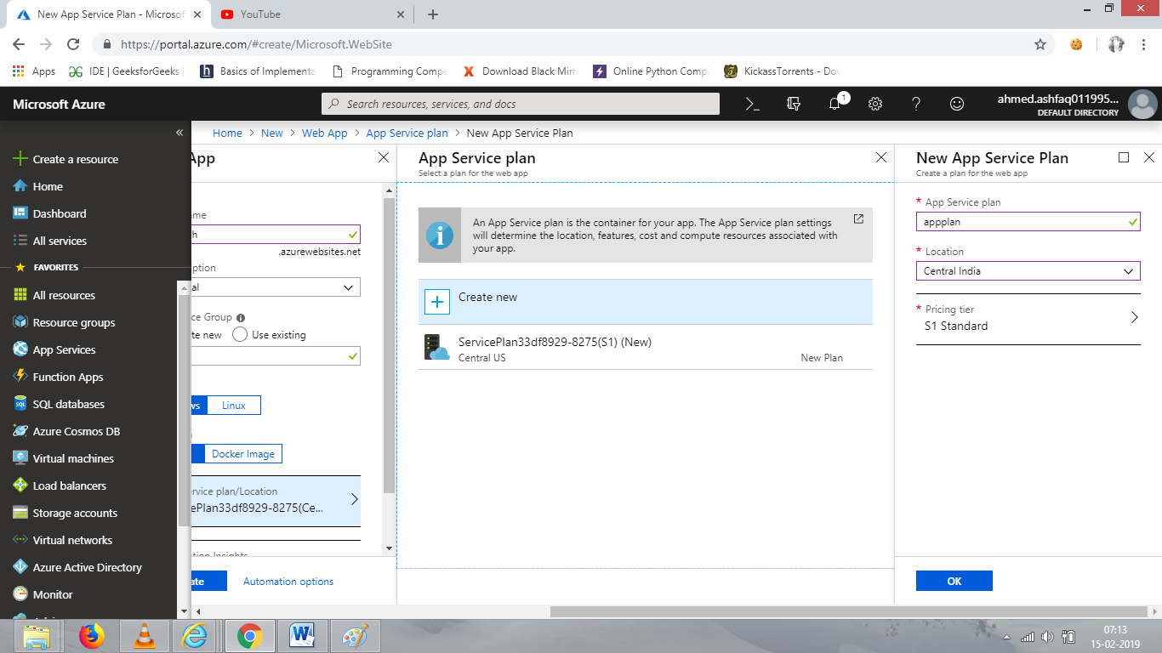

Click on create for complete the create process of web app and it will deploy the application.

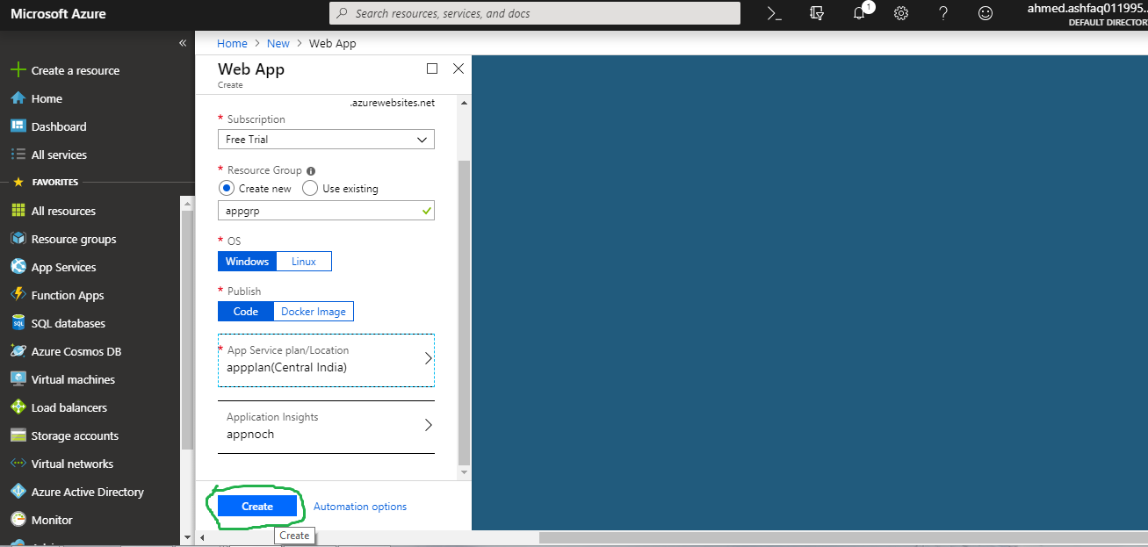

Once the deployment is done we can check it in resource group. There will be the appgroup.

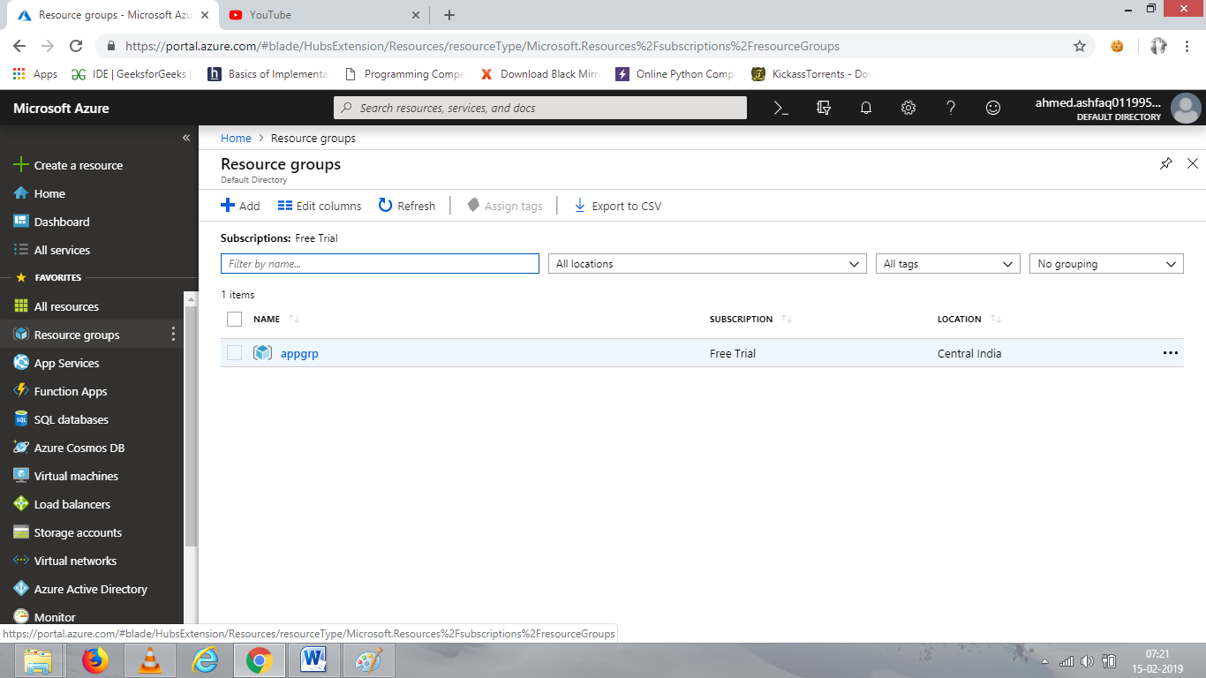

Click on the group created. Inside it there is plan, application insights and the app.

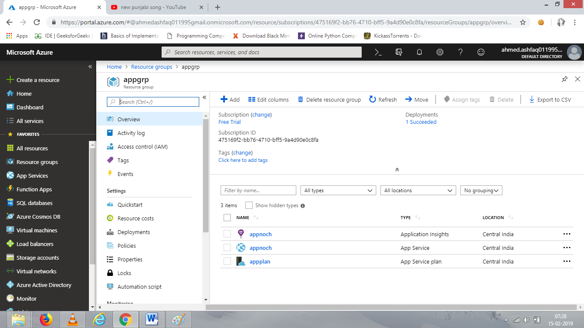

Click on the application, inside that the URL of the website is present.

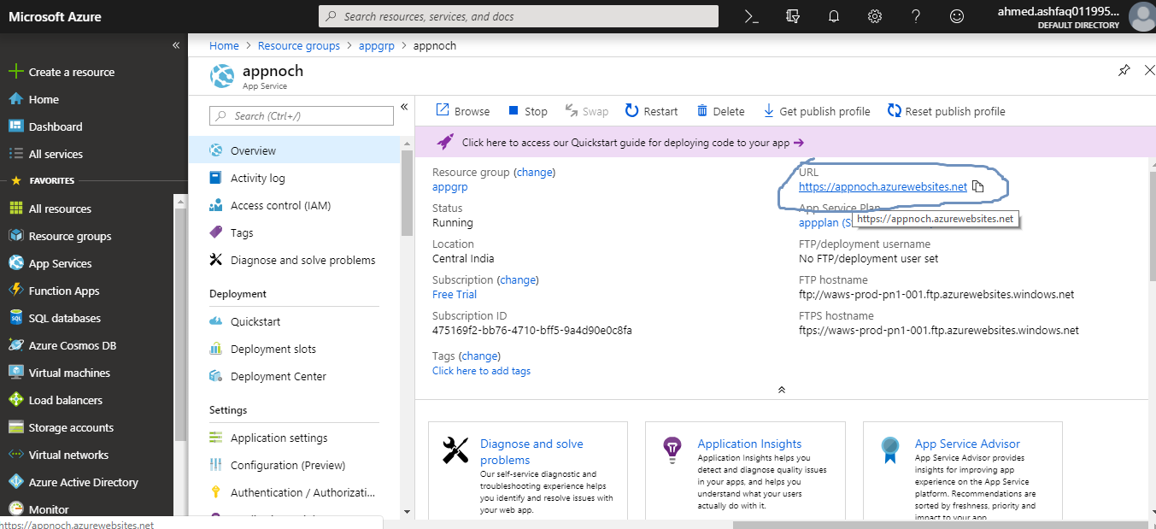

Copy the URL and run it in web browser to check.

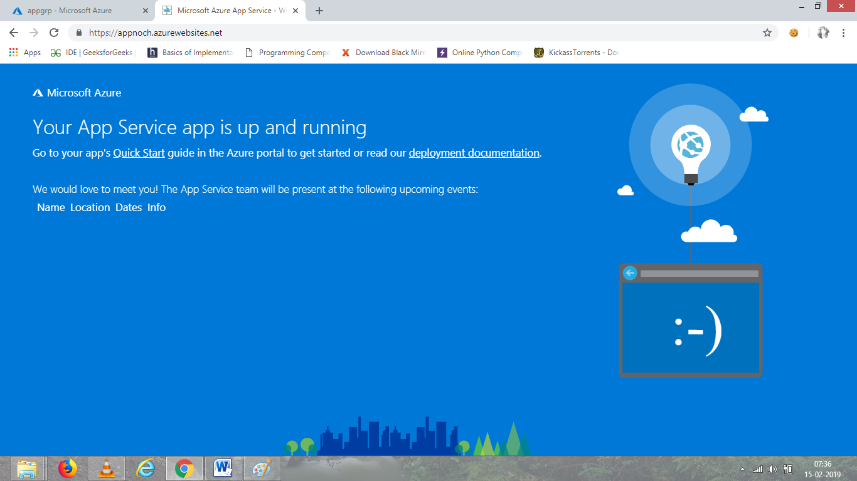

This is the default page of the application.

Now we can host our web page from visual studio, FTP or Github.

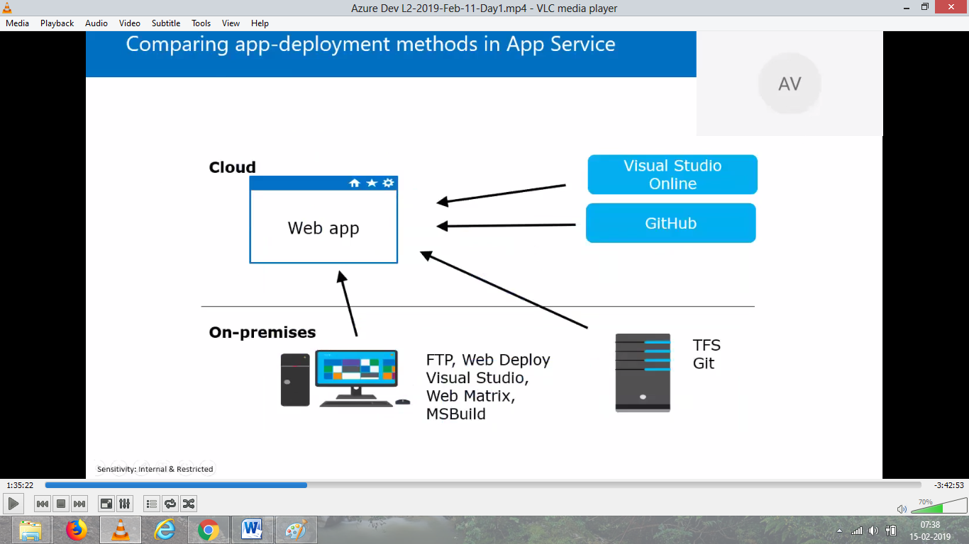

Go to application setting to change any required settings (such as, enable java, PHP platform) after that only the codes of java and PHP, etc. will work. The default is ASP.net.

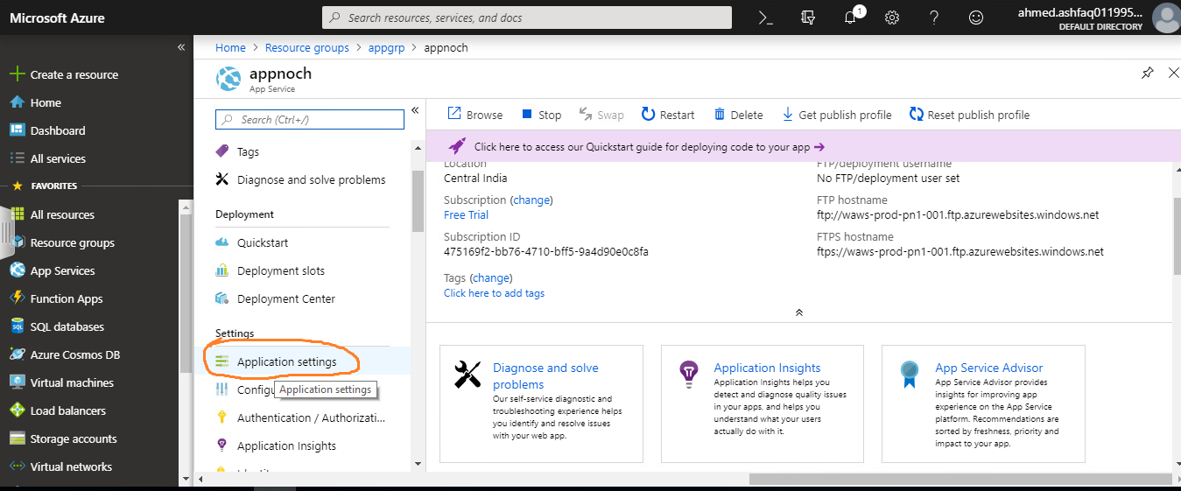

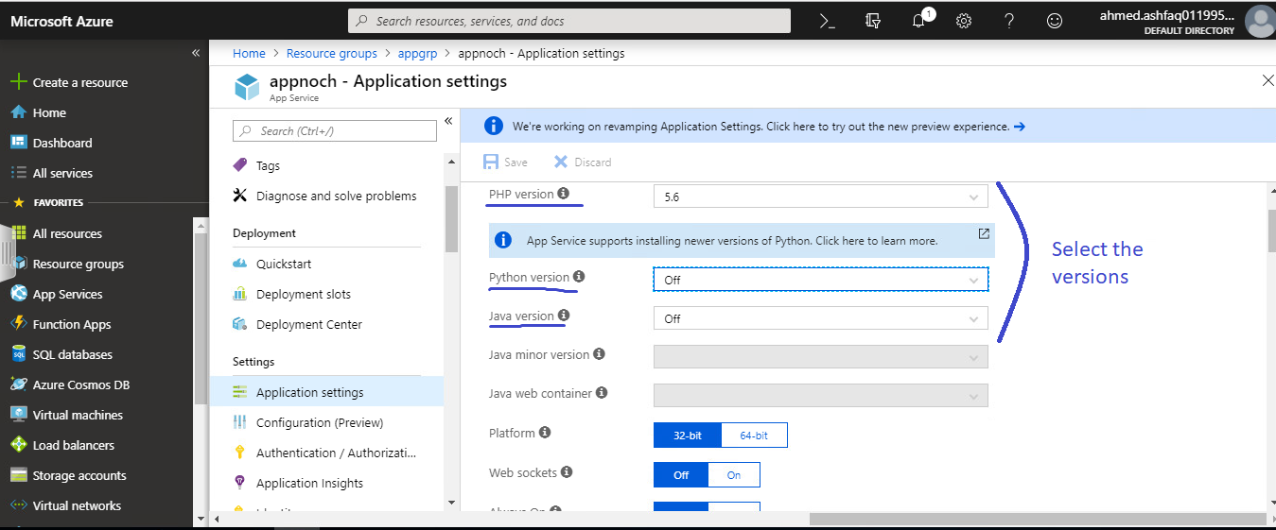

If working in visual studio.

On the debugging and select the version of visual studio system is using for web application.

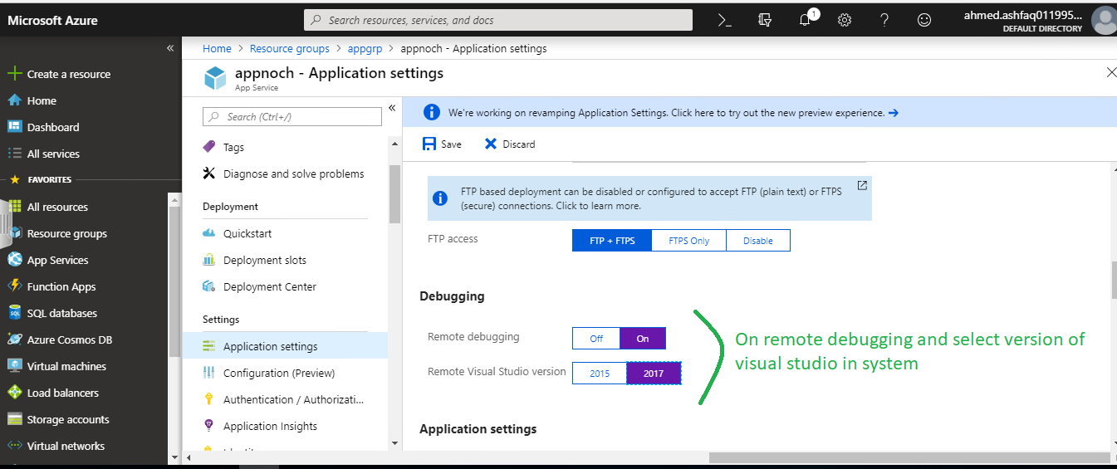

Now open the visual studio and go to new project and select web->ASP.NET web application.

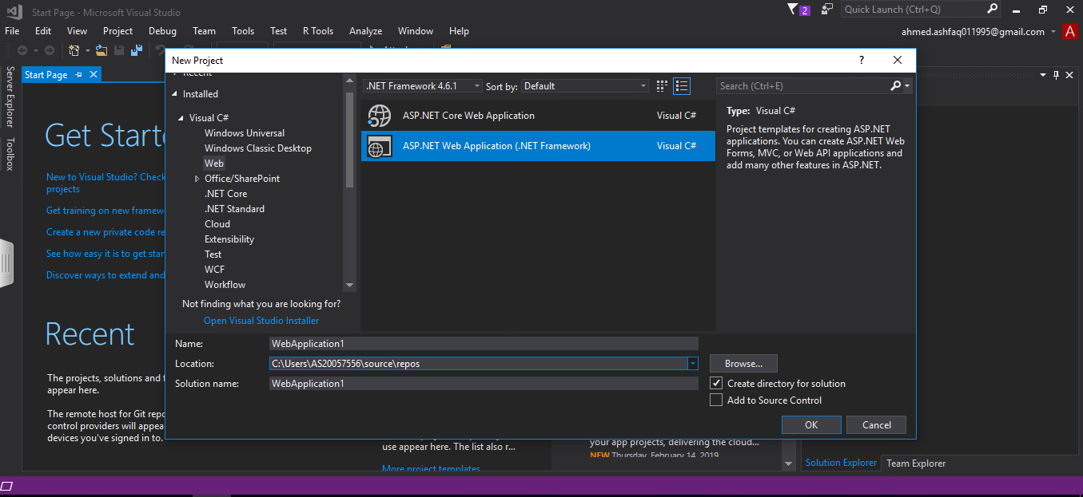

Click ok for creating the web application.

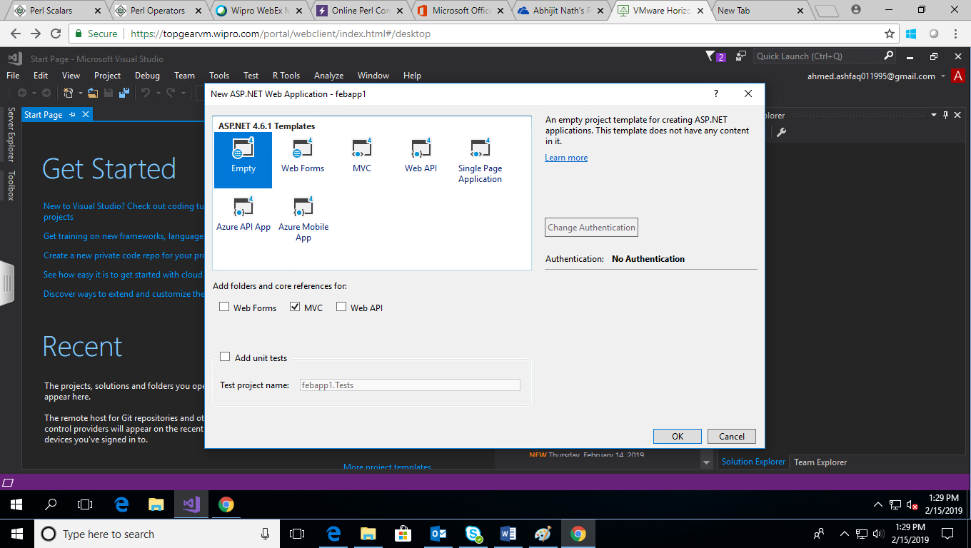

Select MVC empty template for simple application.

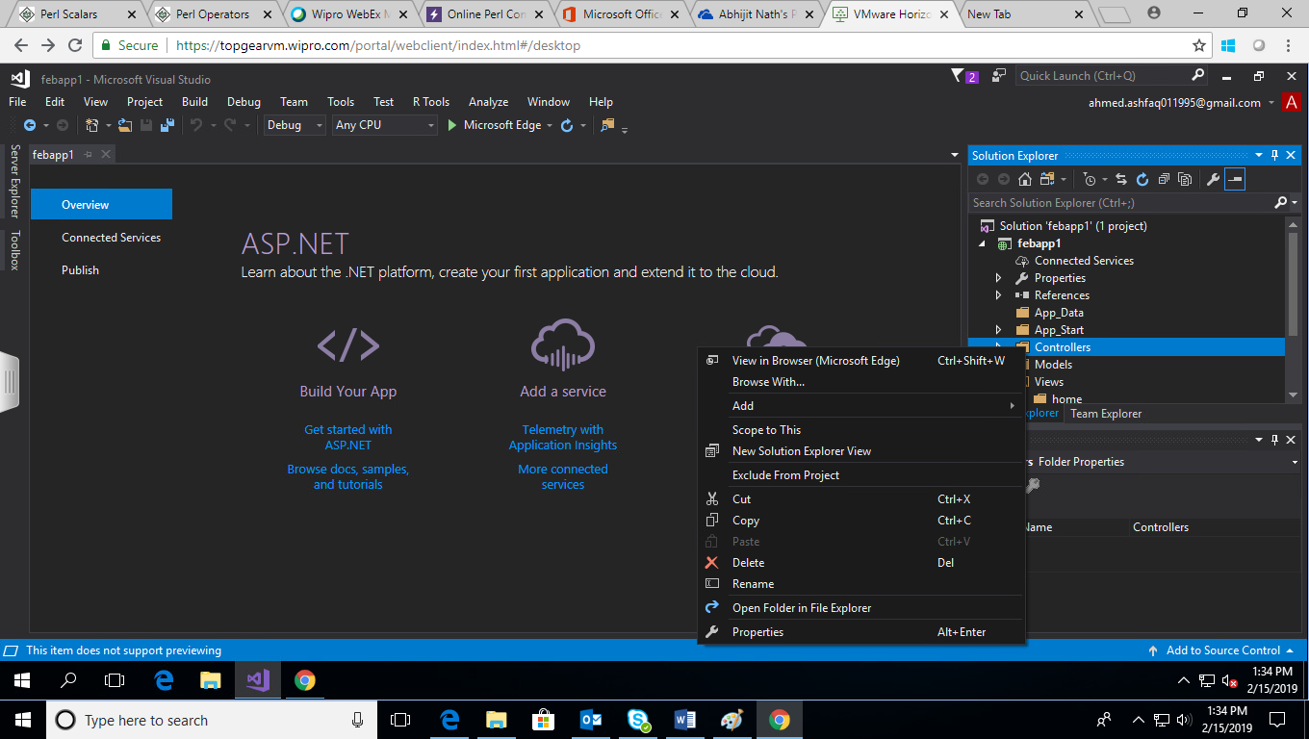

Create a controller by adding a new controller and views for basic checking.

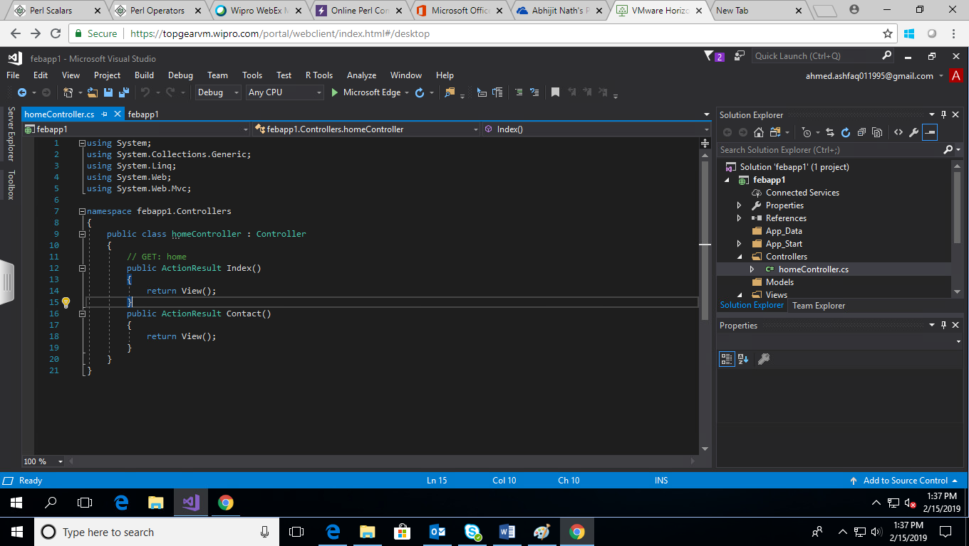

Add views for them.

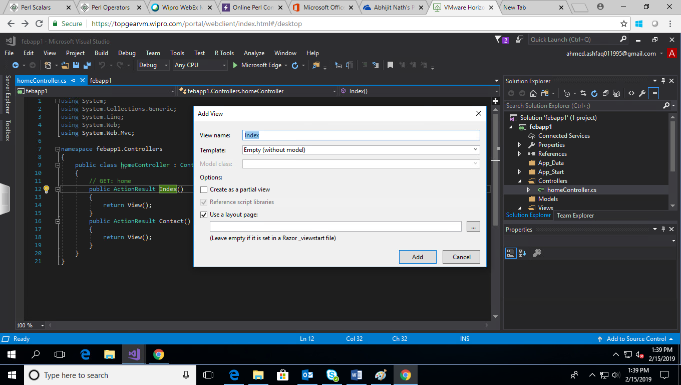

Write some content in view page to display and publish as azure web application.

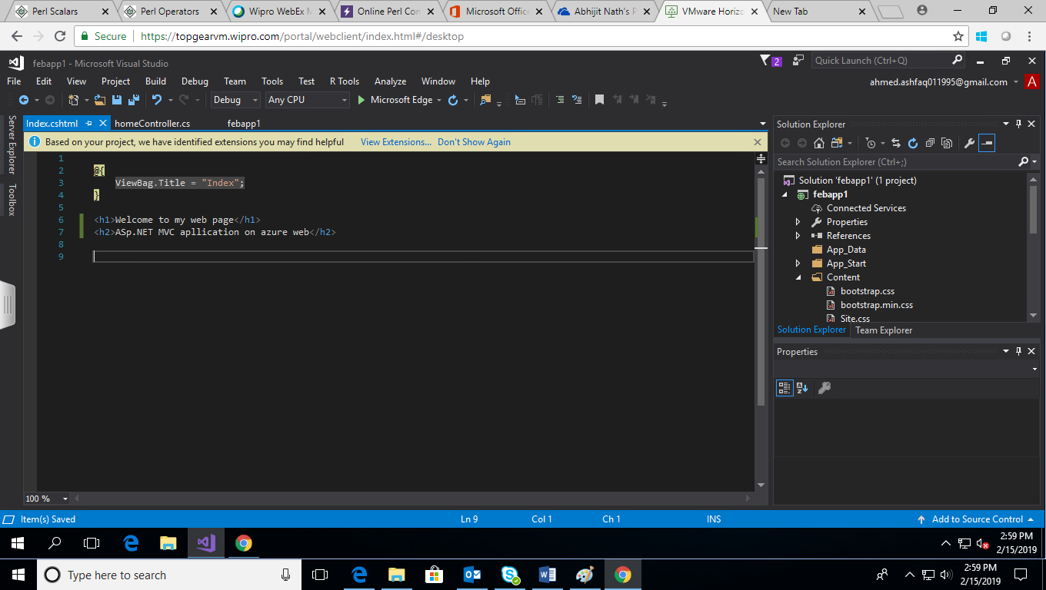

Now build the application.

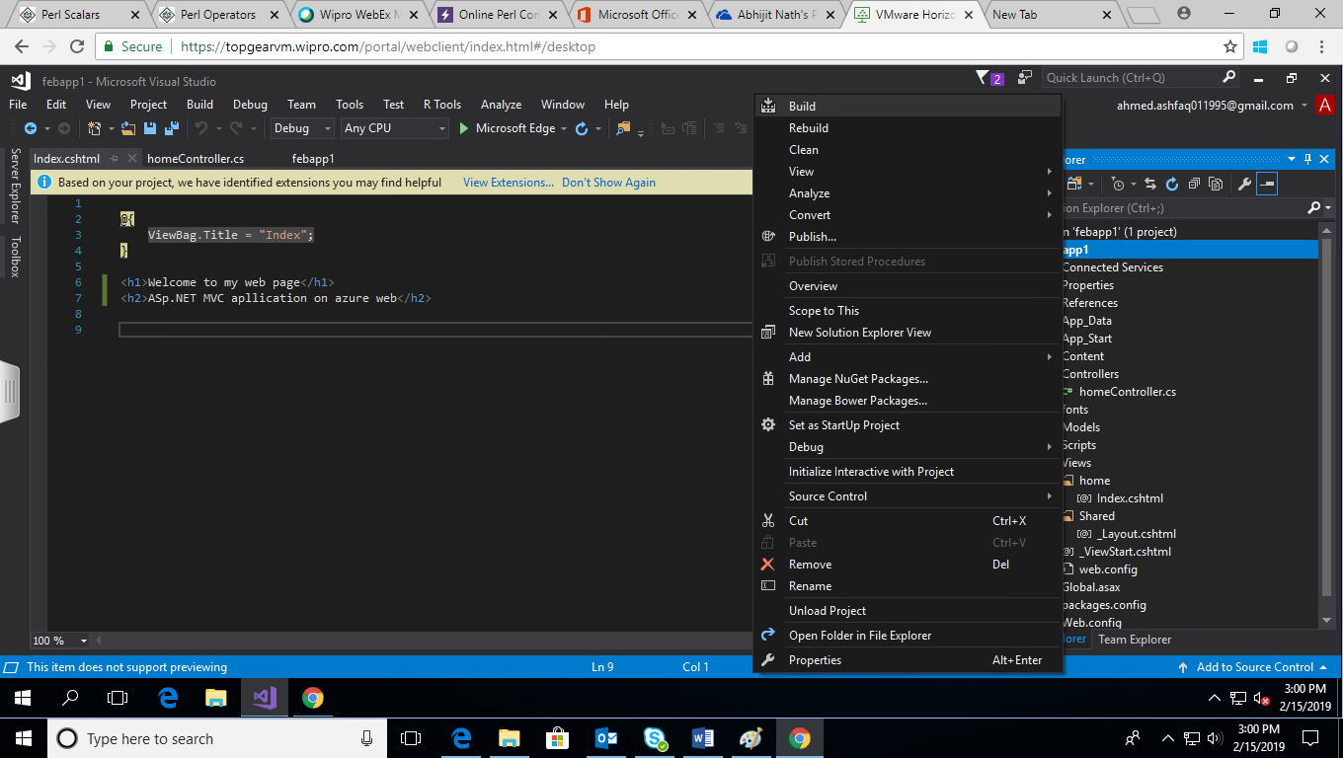

After build successfully. Try it as localhost first checking it is working or not.

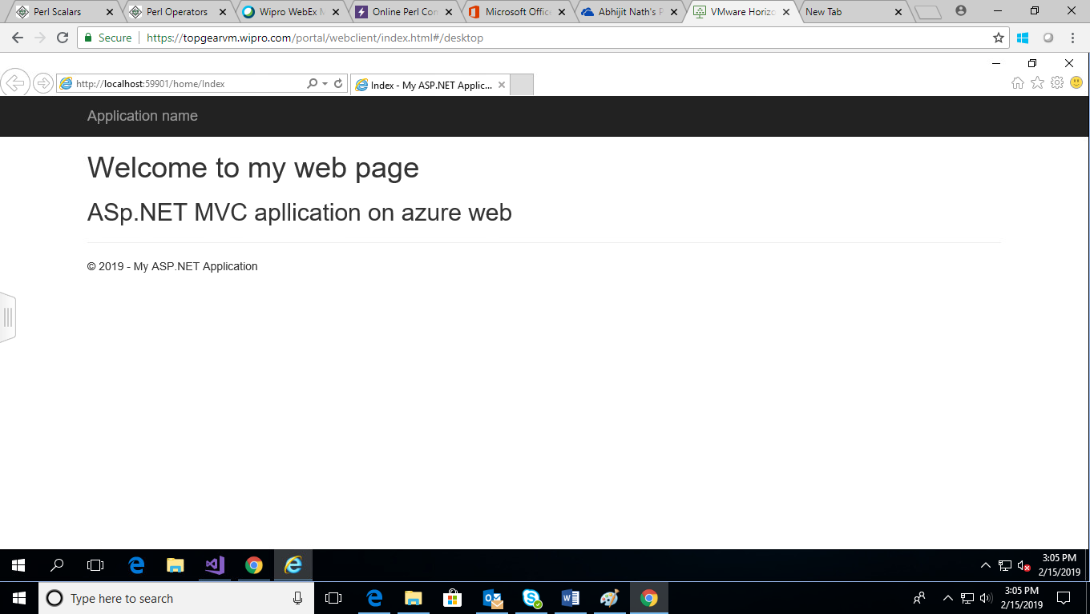

After checking go for publishing the web application in azure.

To get publish profile go to azure portal and click on get publish profile

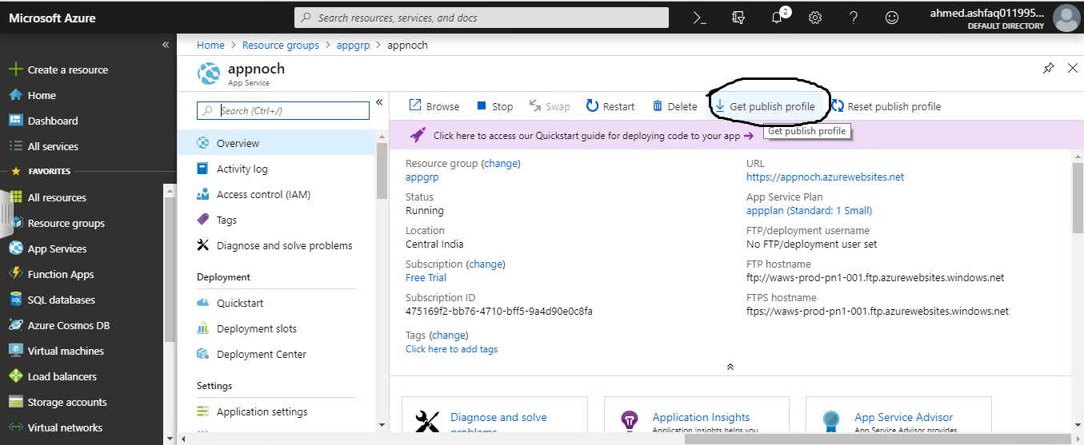

Now go to visual studio and get application publish

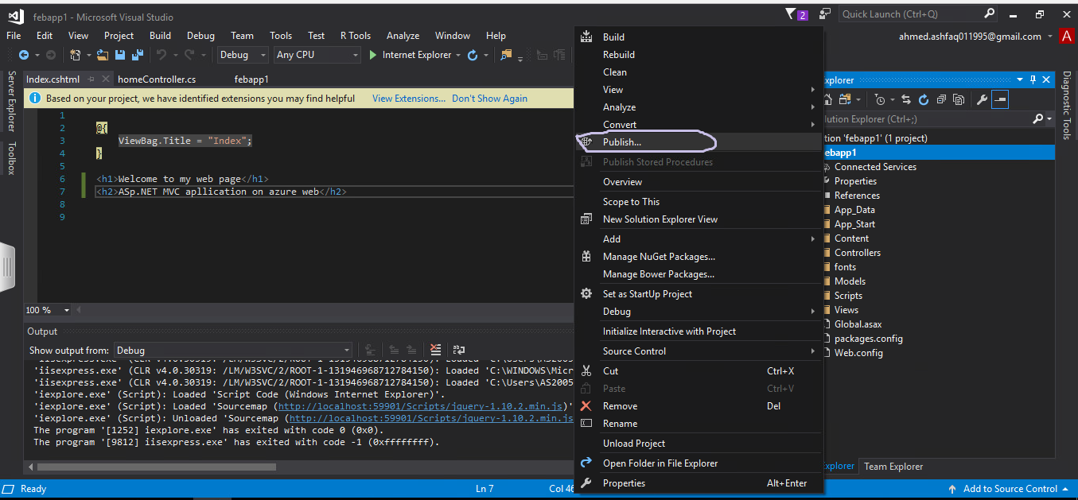

Click on publish as show in above figure.

Select Microsoft azure web services and select existing profile then click on publish.

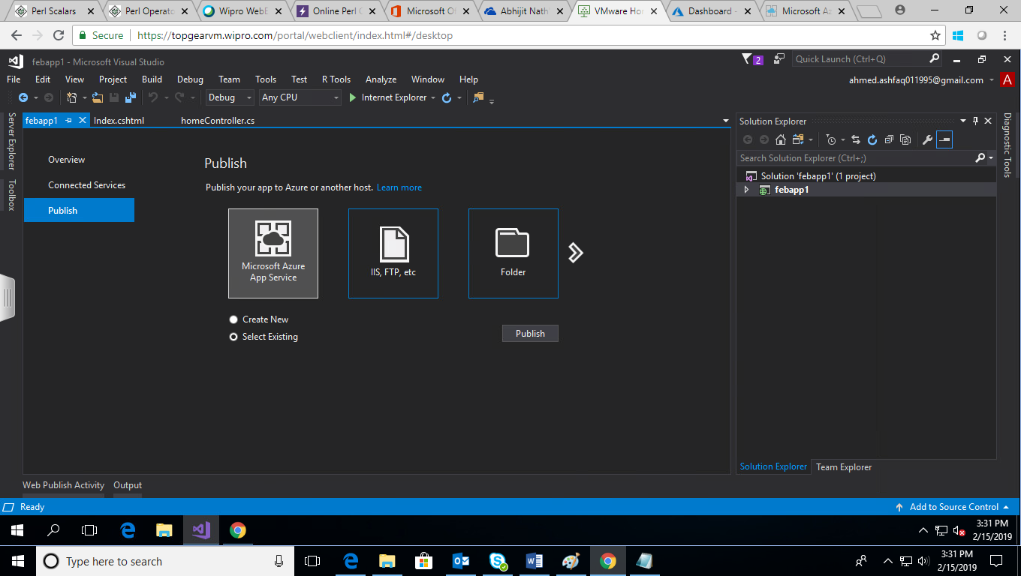

Select the web app and click on ok.

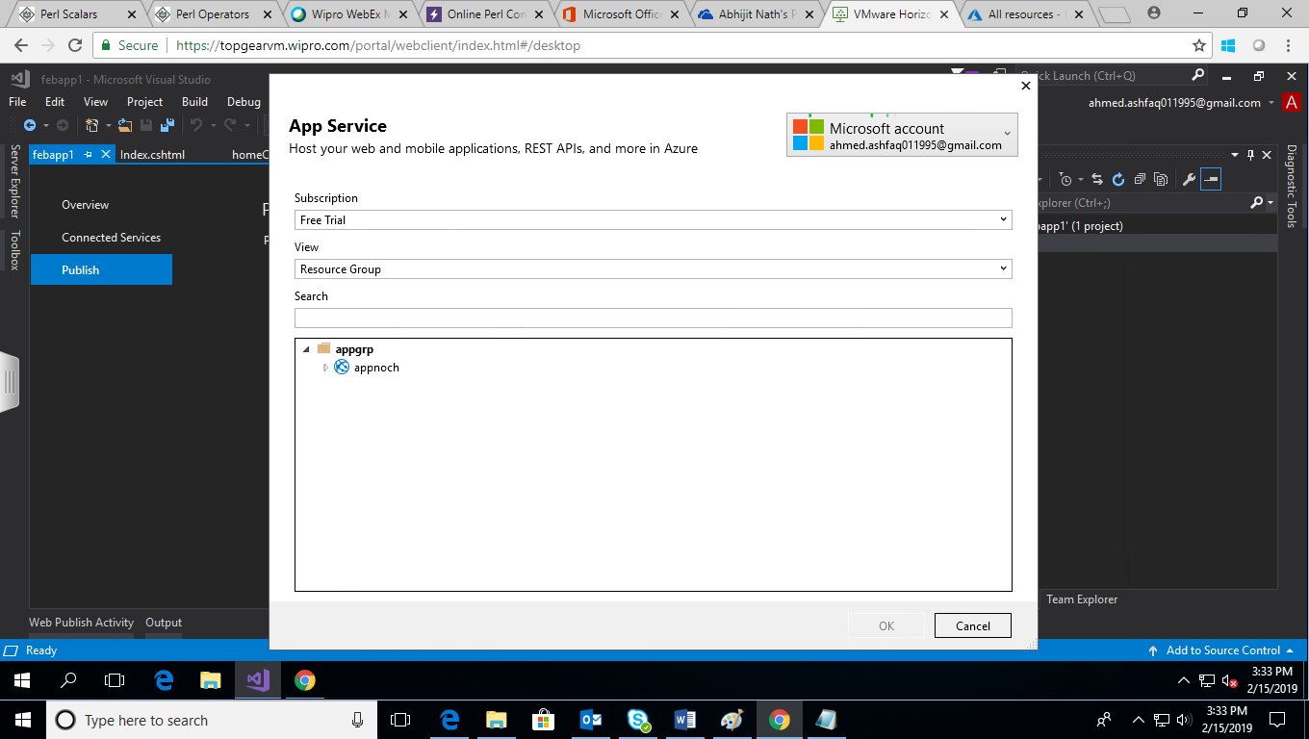

After completing the publishing it will display successfully publish and provide the link for that.

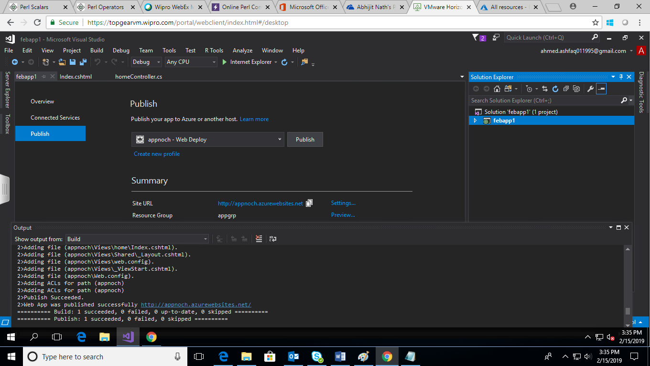

The page is not published and can be visited in internet.

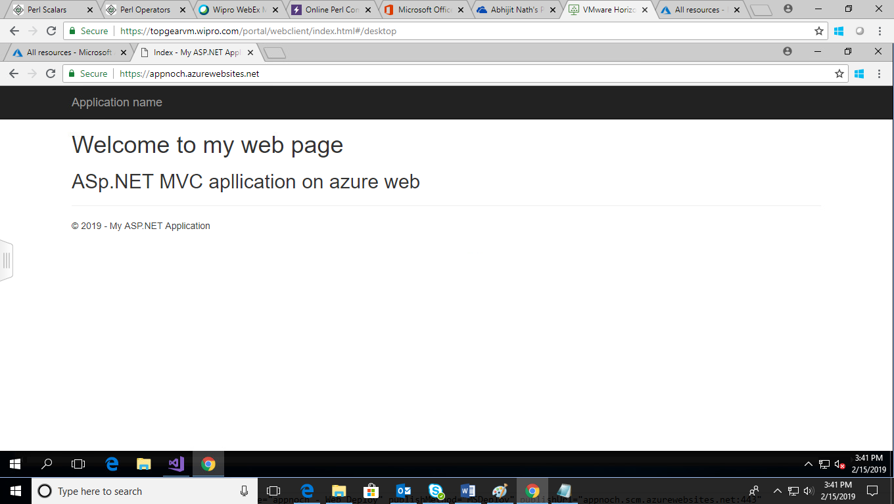

**Deployment by GITHUB**

Create a git hub profile and upload file to the repository.

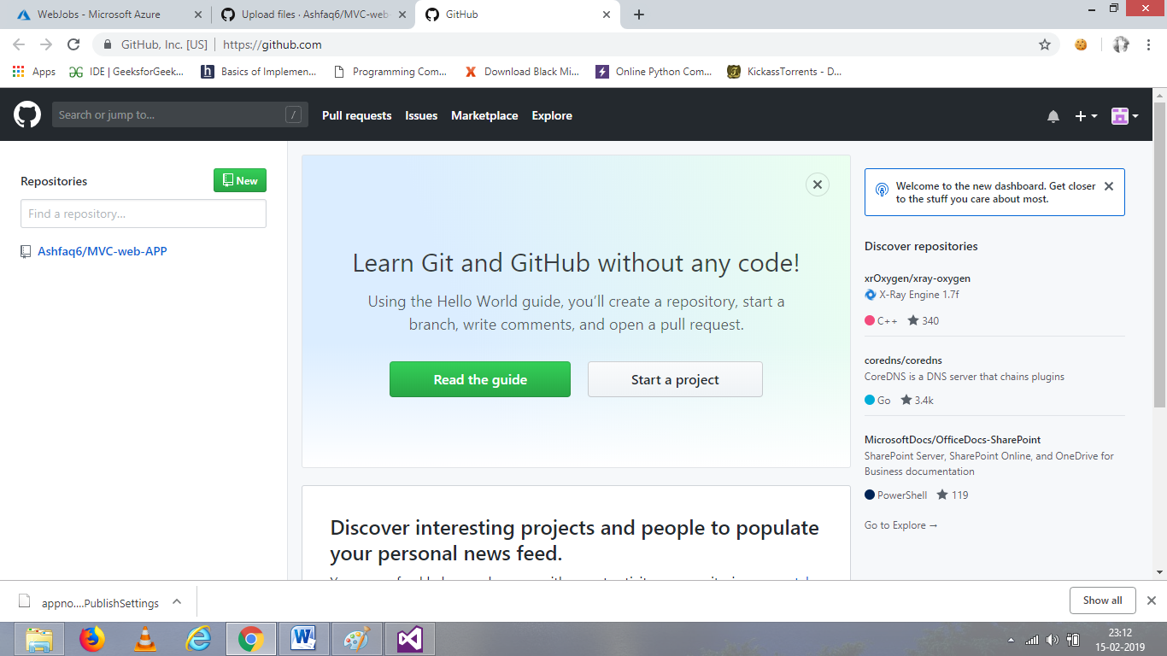

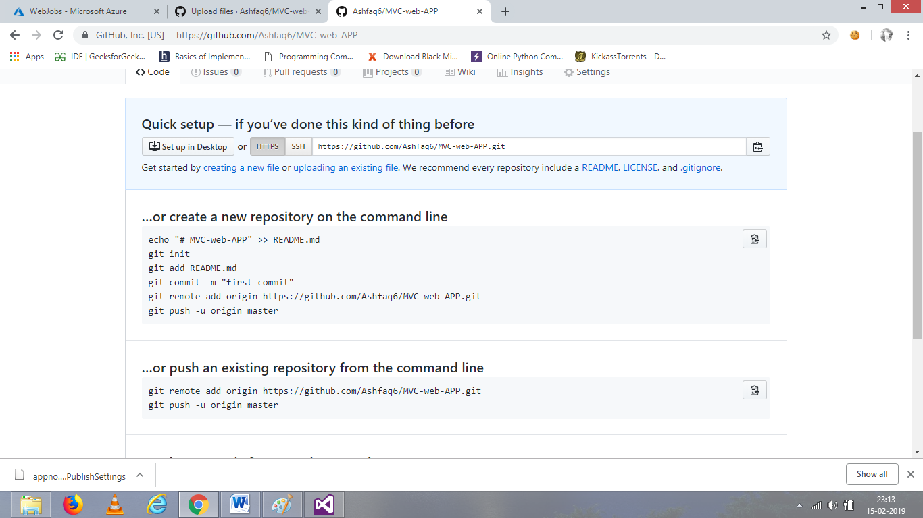

Create a deployment slot, and then we will pass it to app server.

This is for secure and bug free computing.

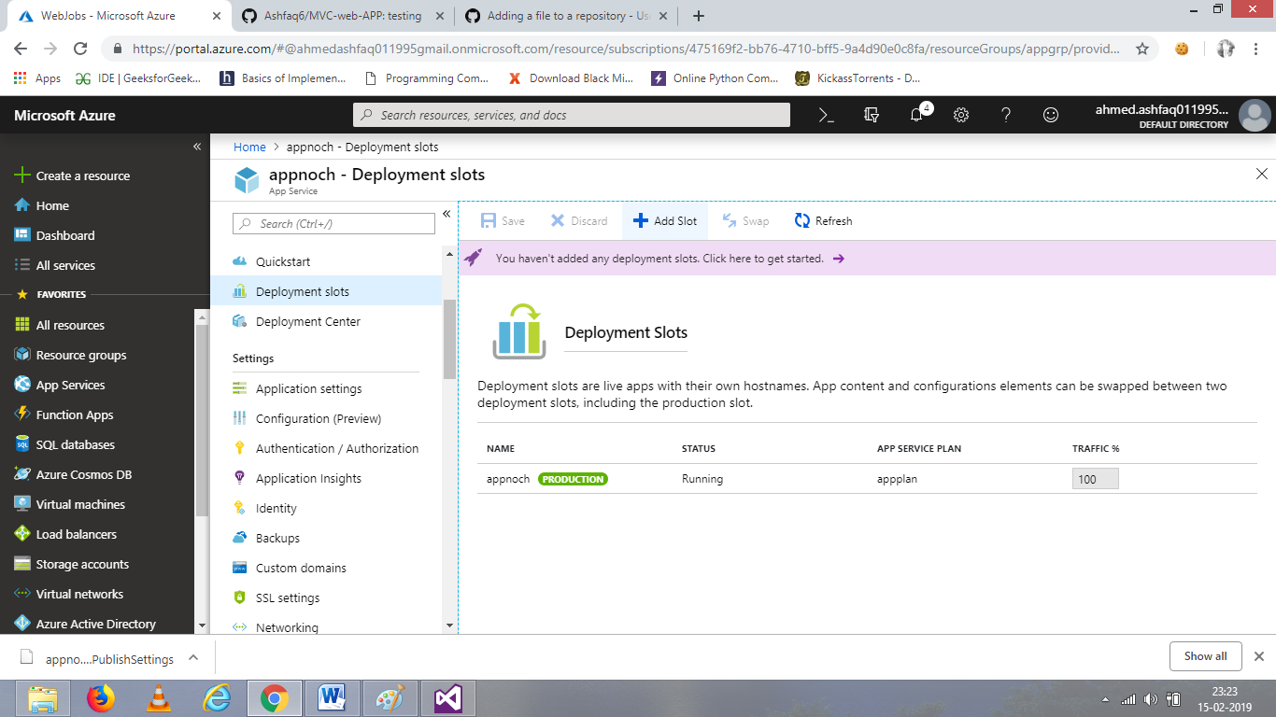

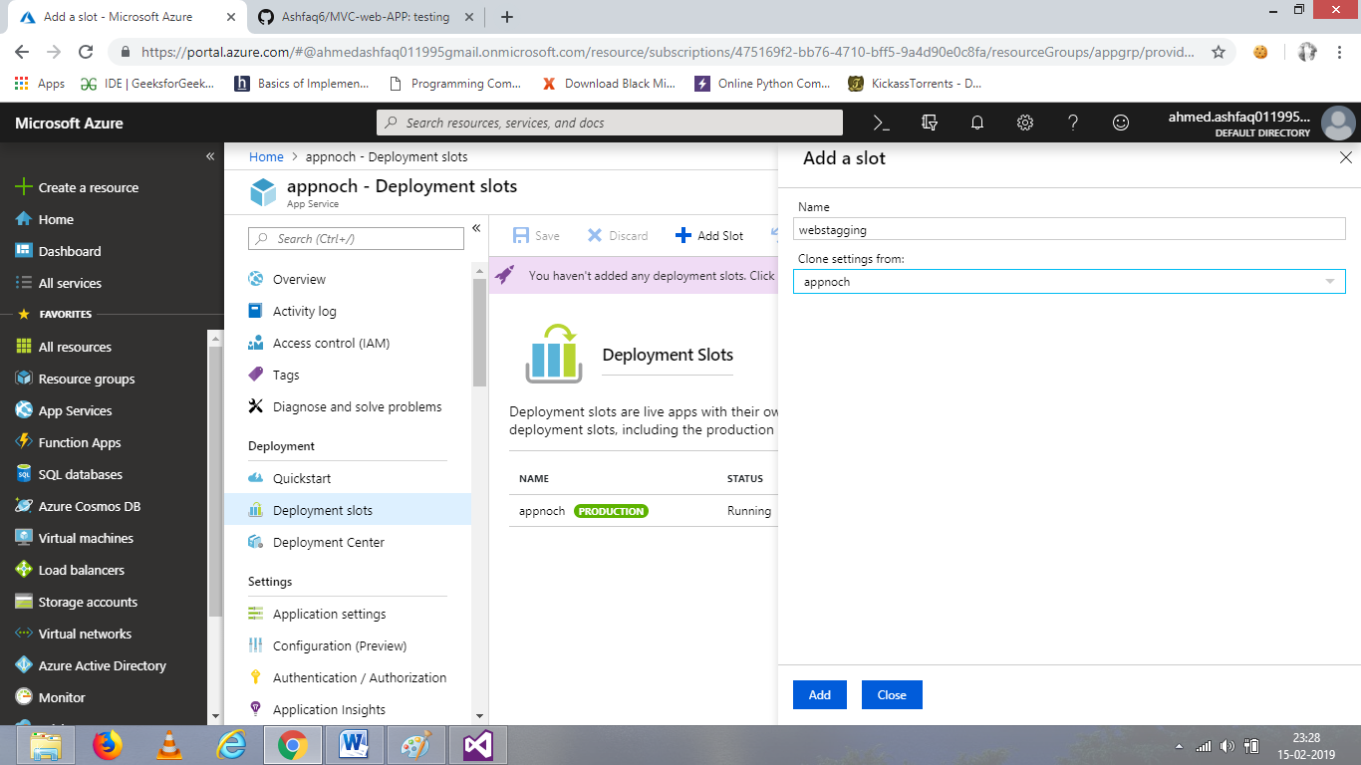

Click ok, after giving name and clone setting.

It will be displayed in the group.

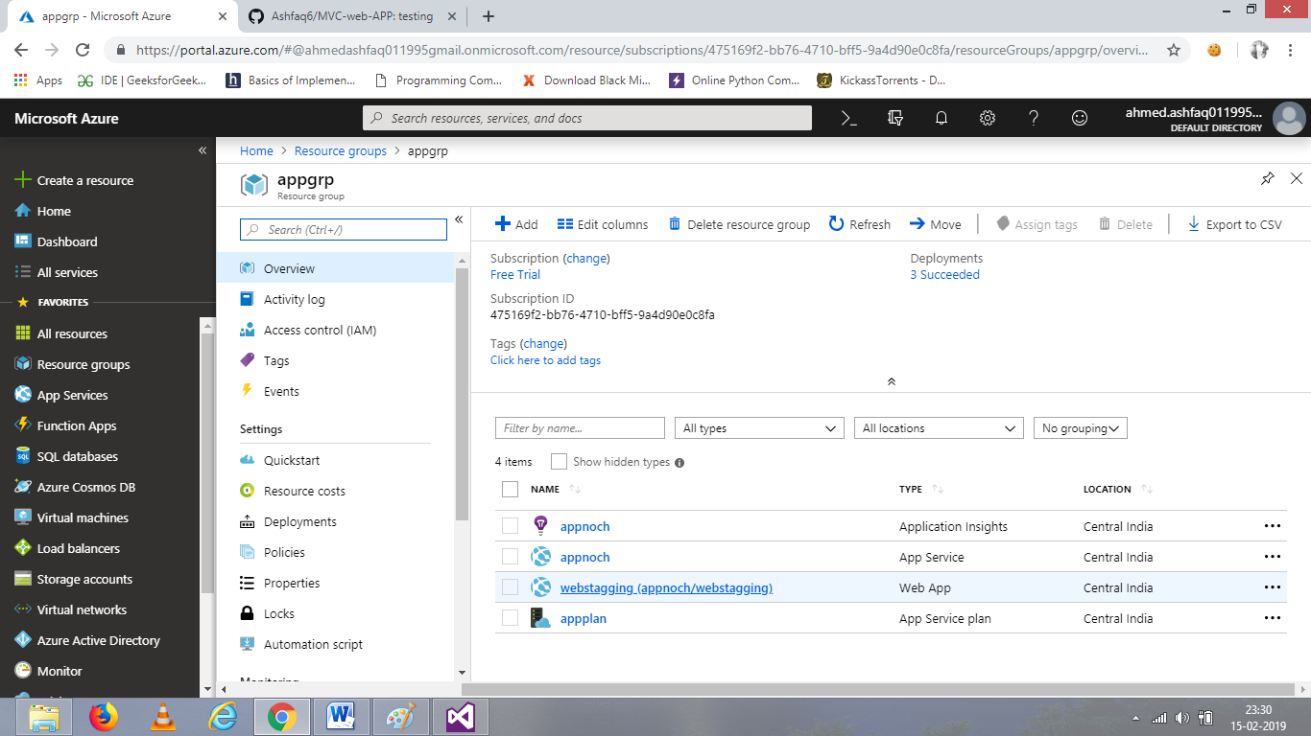

After entering the web staging, go to development centre to connect with git hub

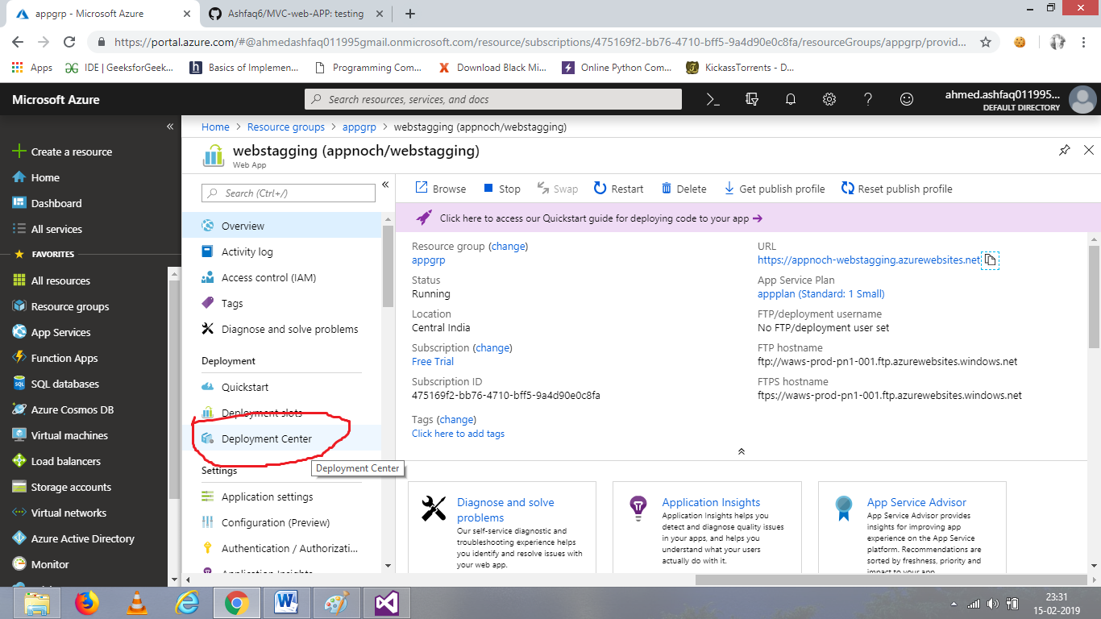

Click on git hub and connect it with git hub profile.

Click continue to proceed.

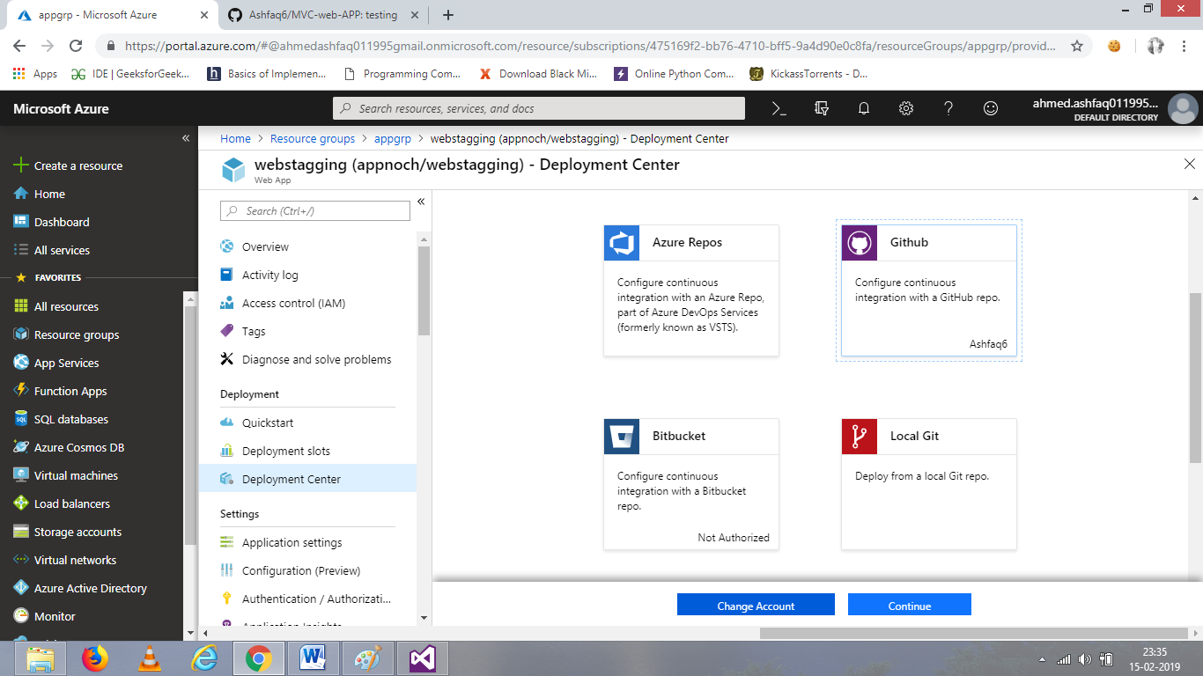

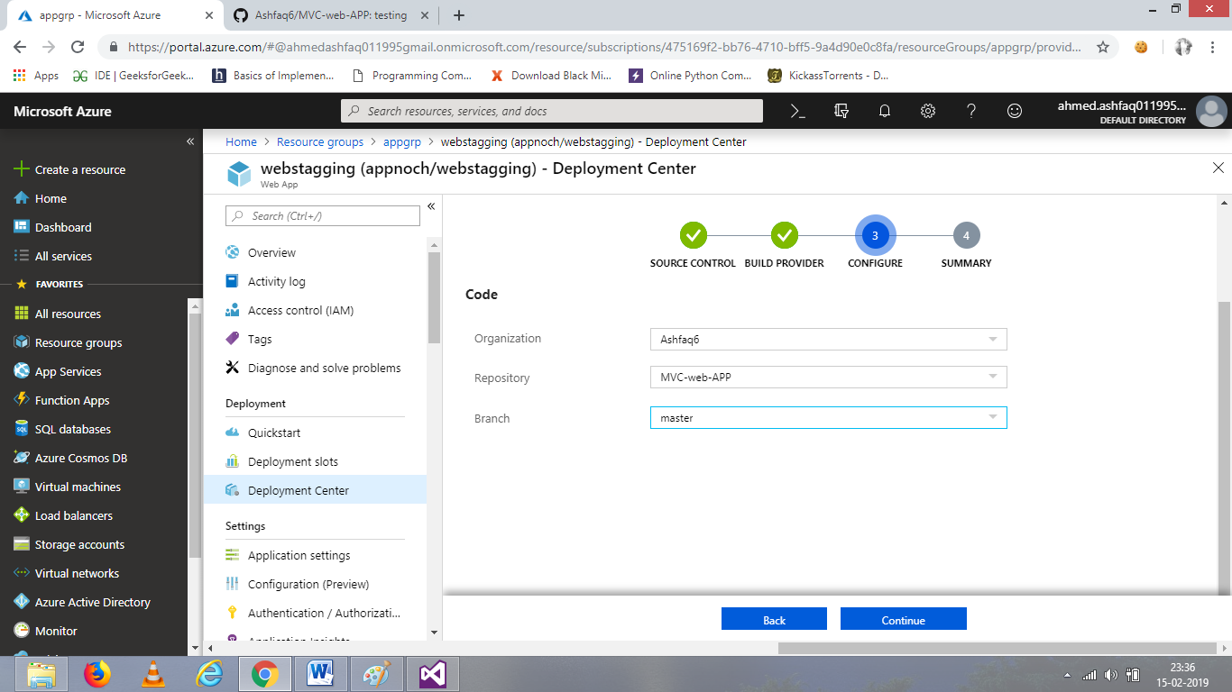

Select the repository and branch and proceed.

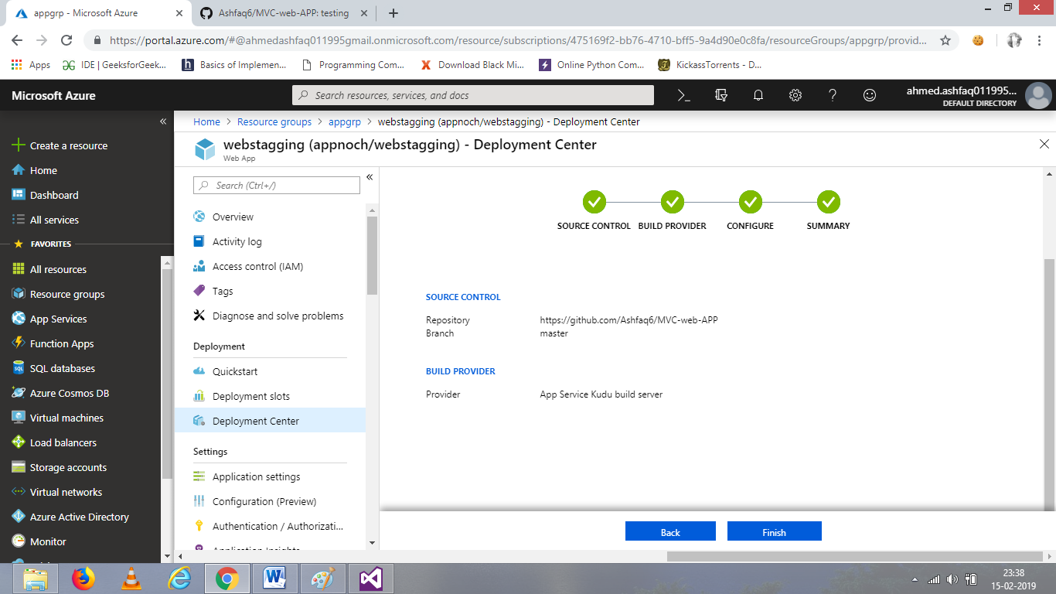

Click on finish.

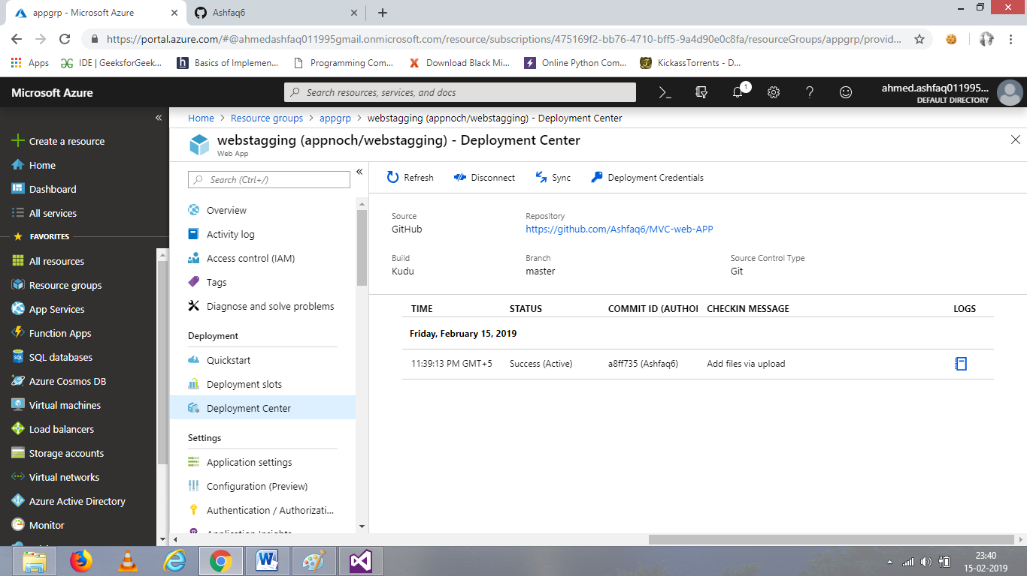

These how git hub file is integrated.

**CREATING WEB JOBS**

Go to web jobs and add new file

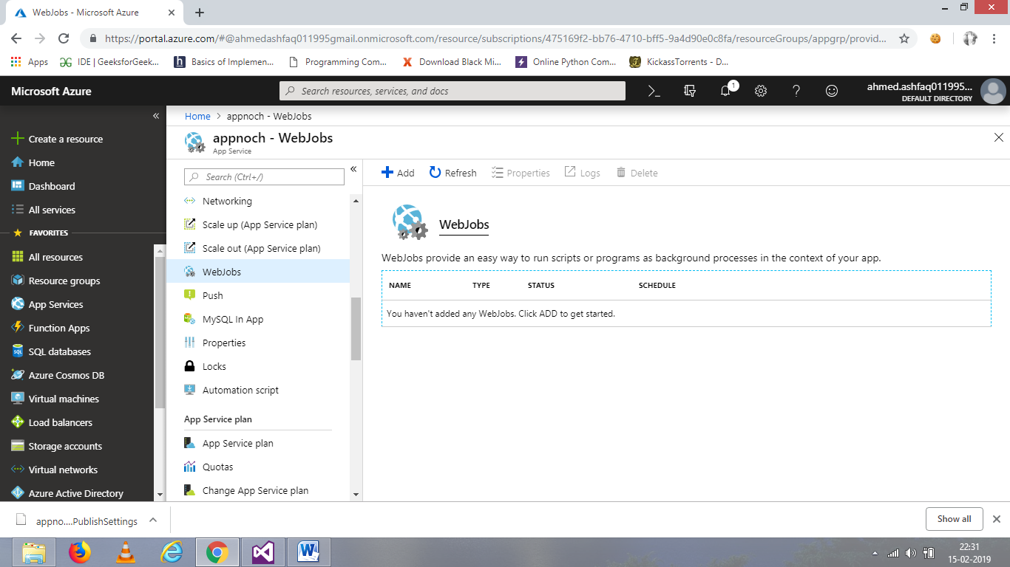

Create a file ,it can be(java, PHP etc.)

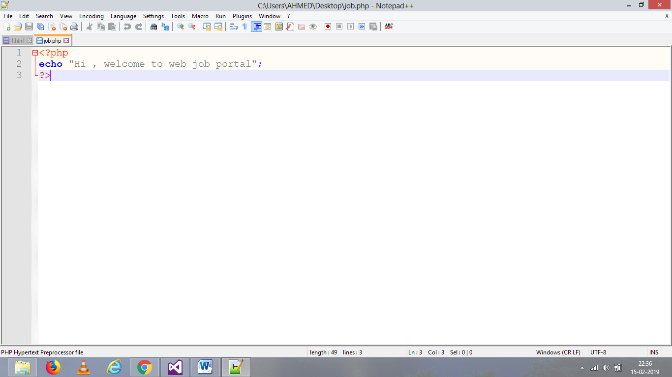

Save and then add new web job

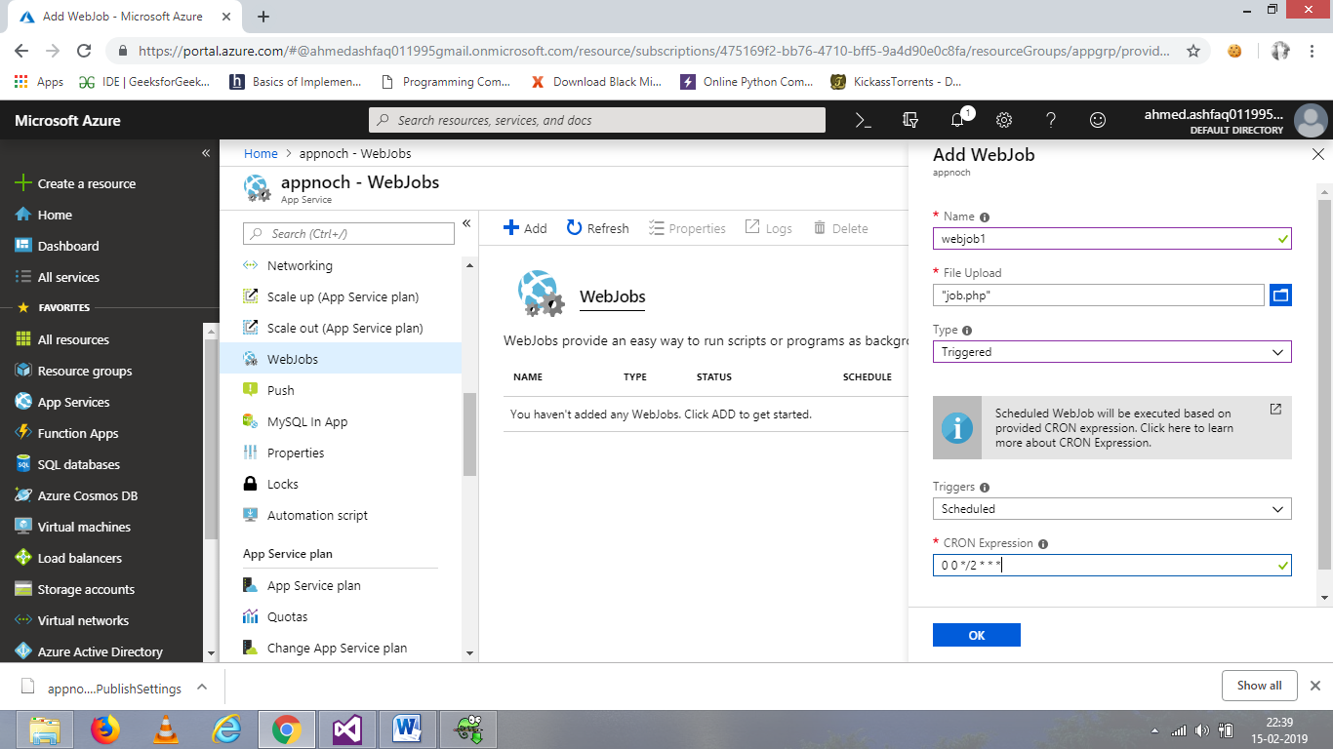

Give name to web job, upload the file and select the type. Fill CORN expression according to the rules and click ok.

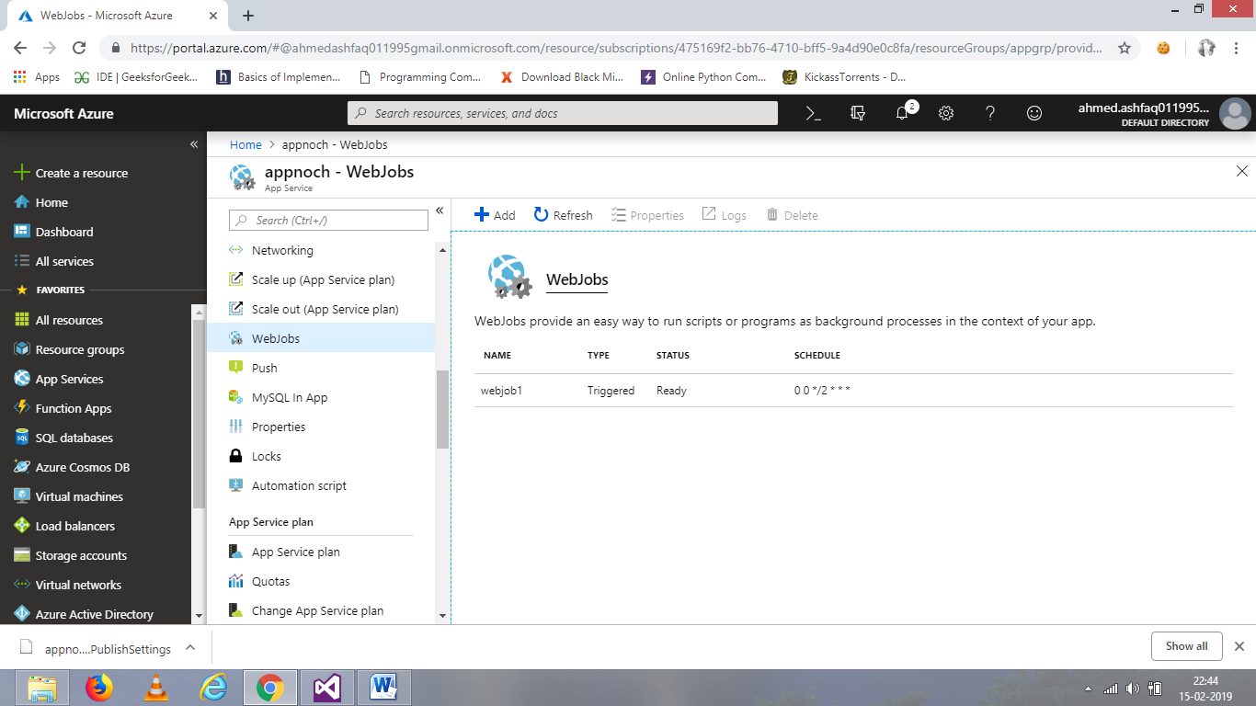

If want to run the web job, click on run.

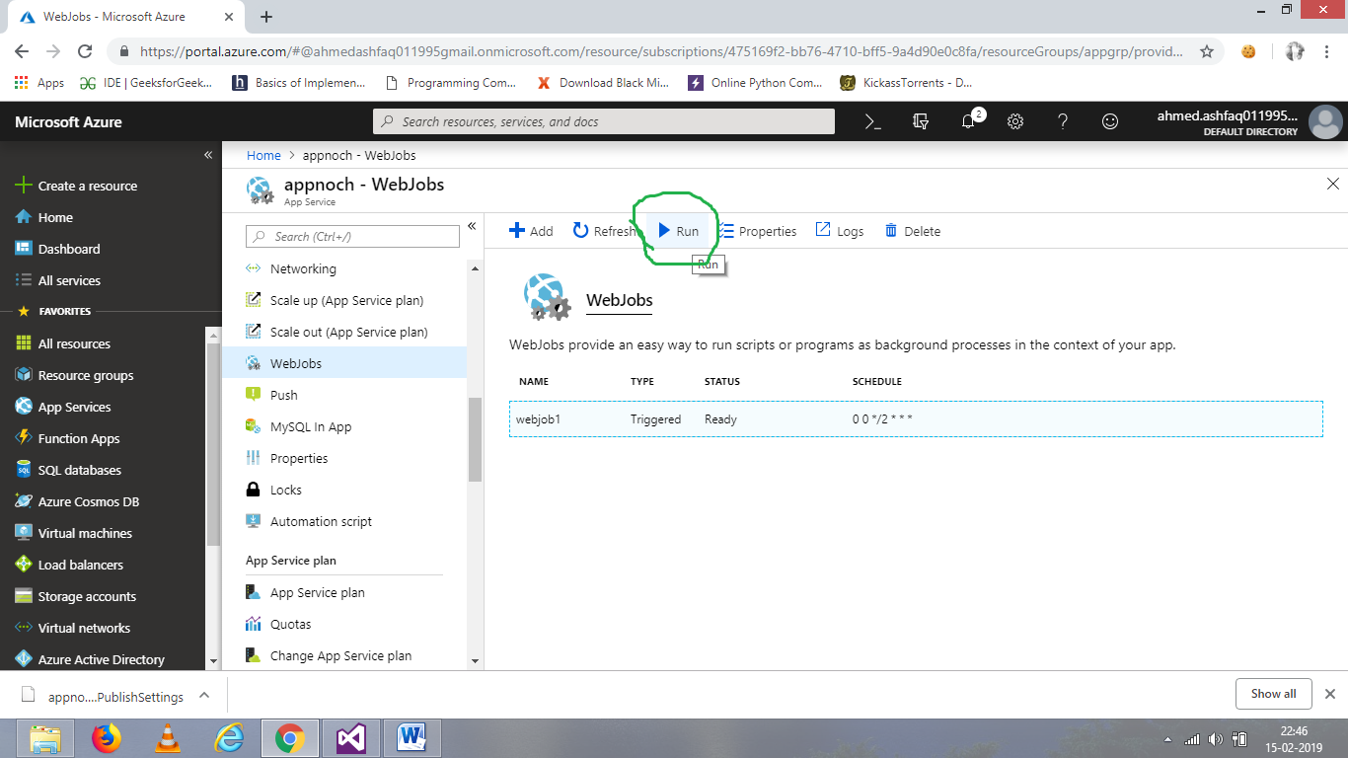

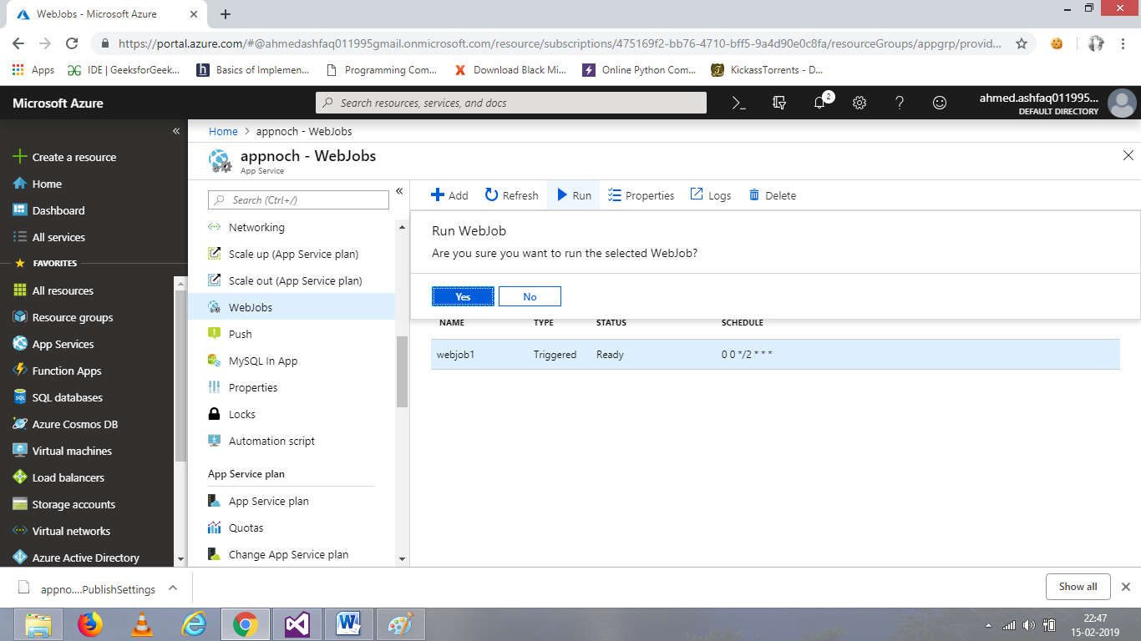

Click yes to run.

To visit the job click on logs.

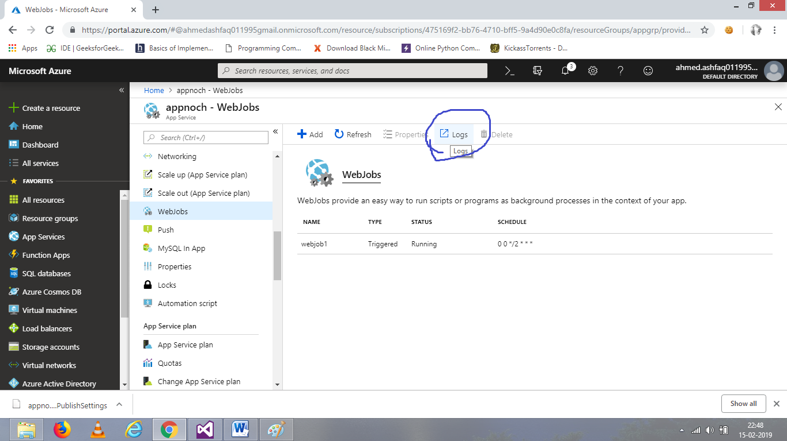

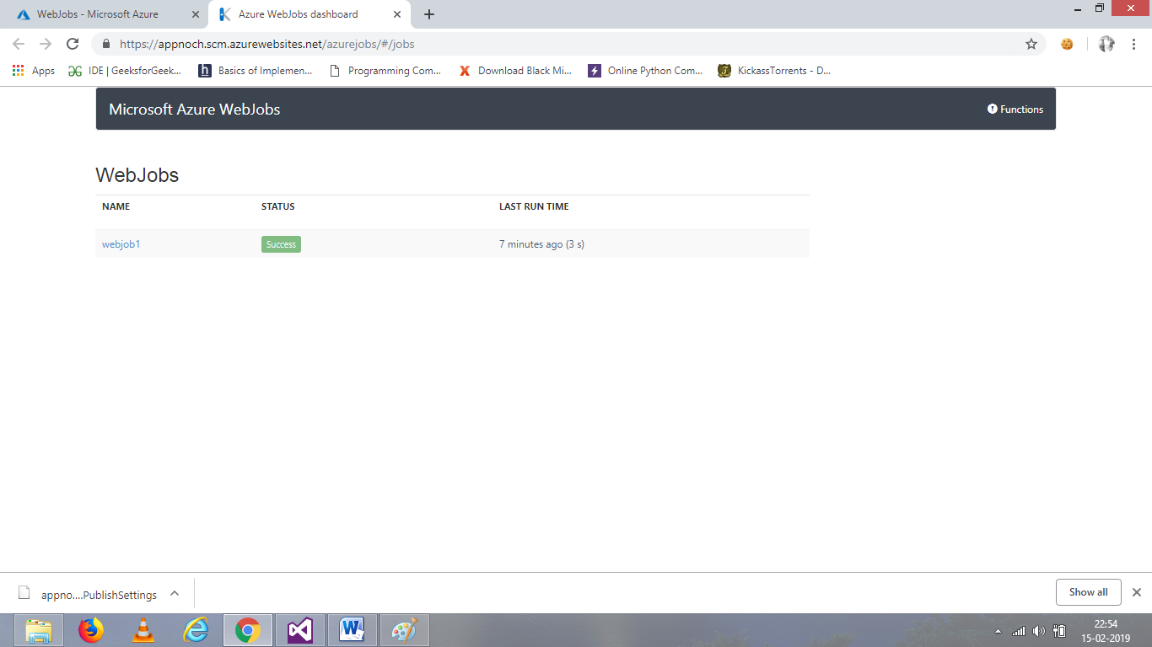

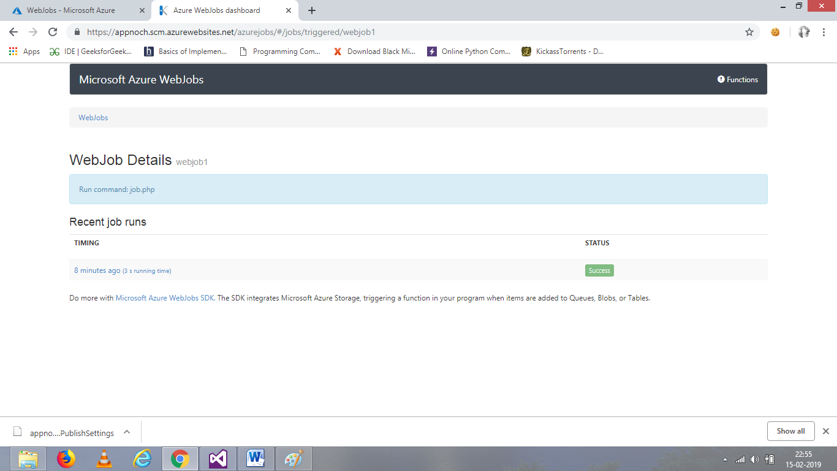

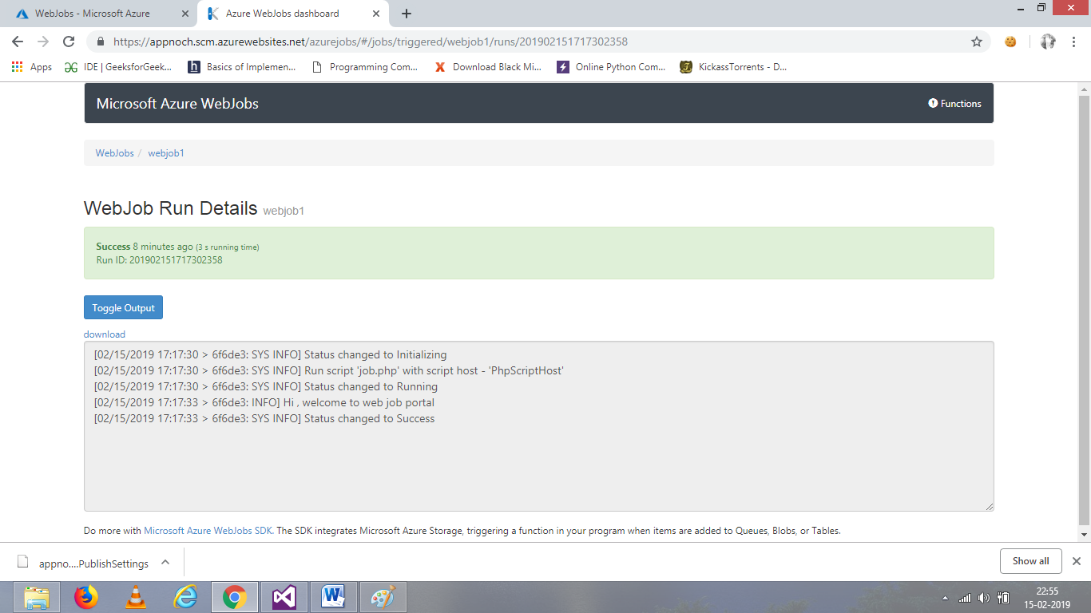

For creating web jobs by visual studio. Go to visual studio->project->Azure web job

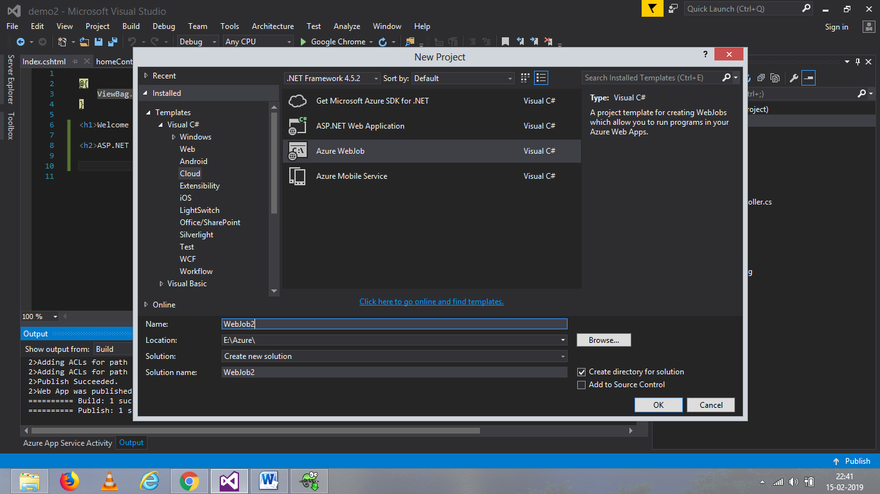

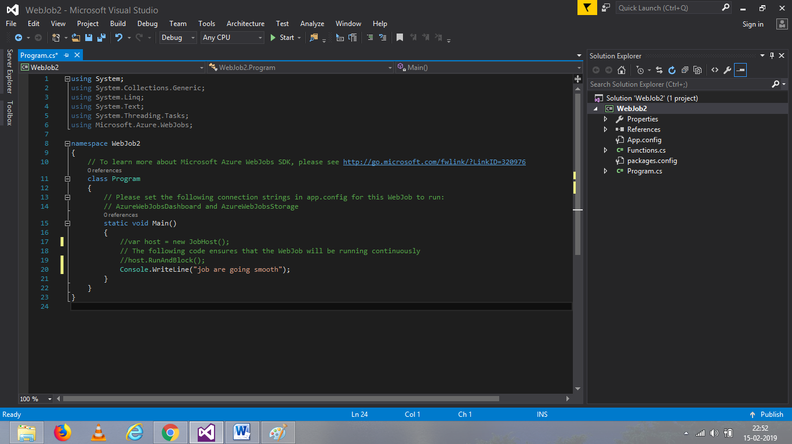

Build and publish the web job.

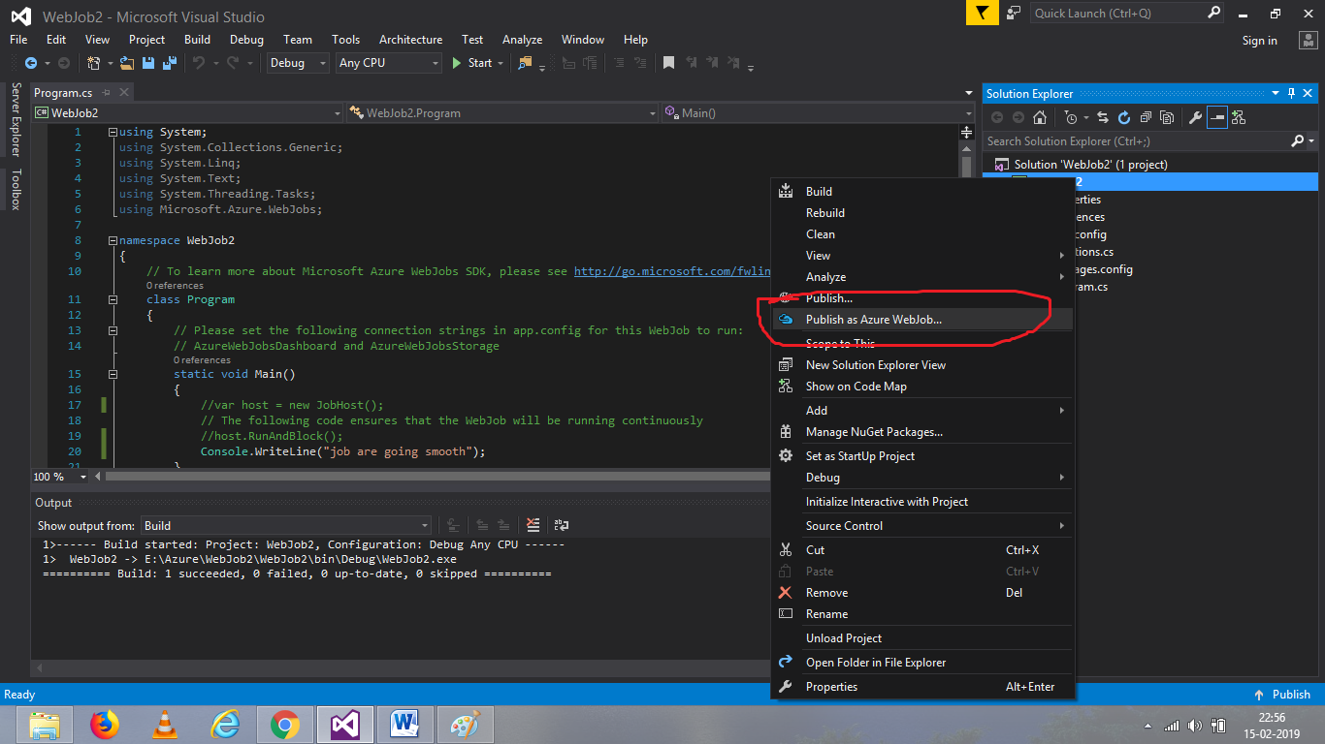

You can schedule the job according to need and click ok.

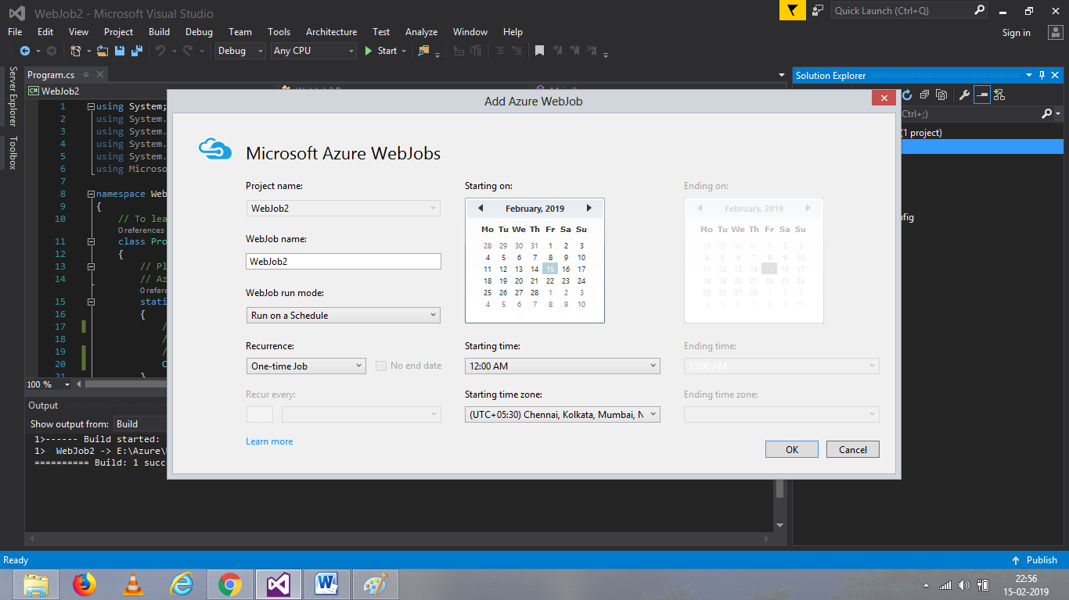

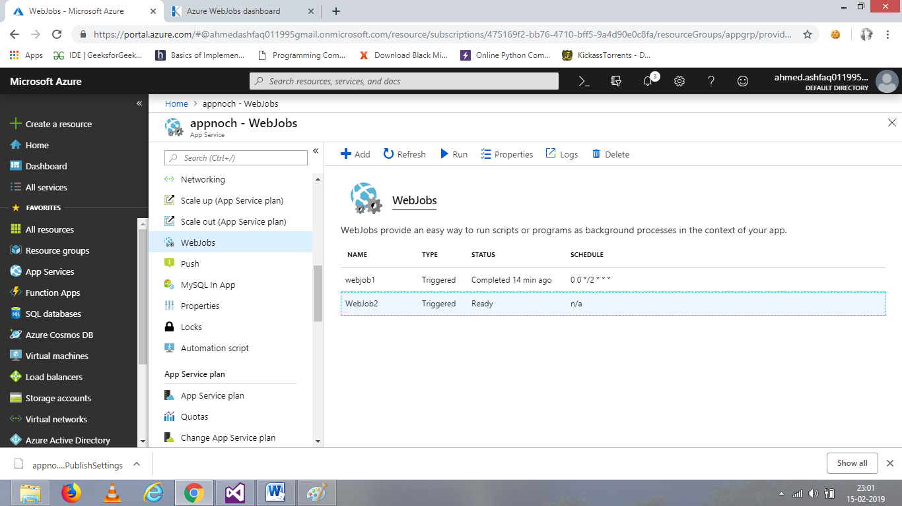

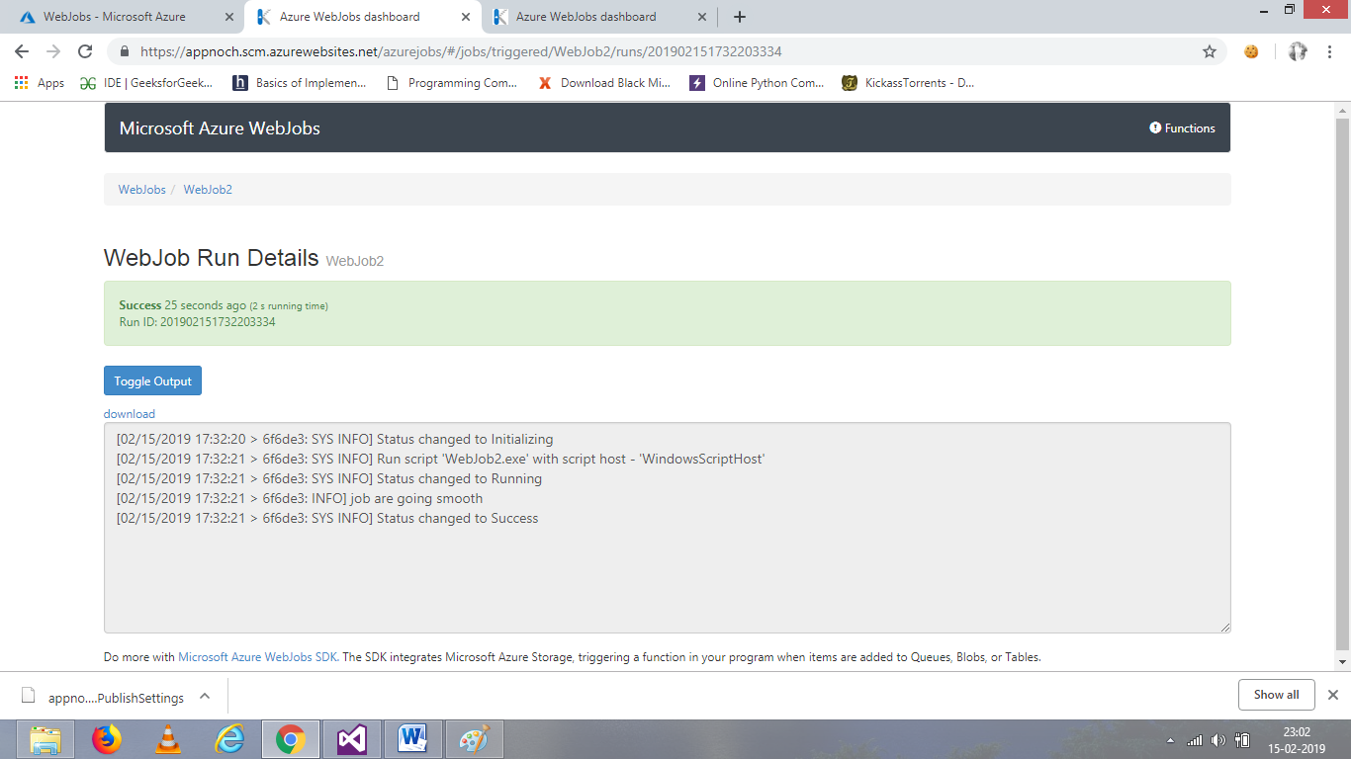

**WEB APPLICATION USING AZURE SQL DB**

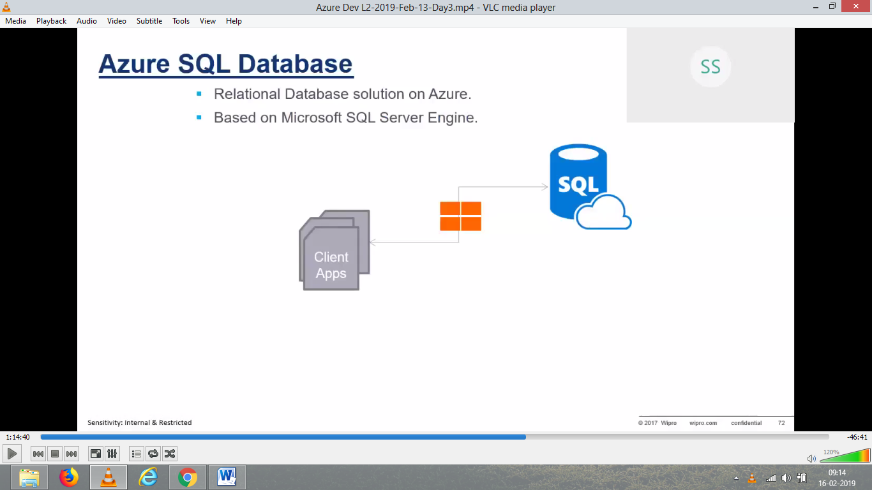

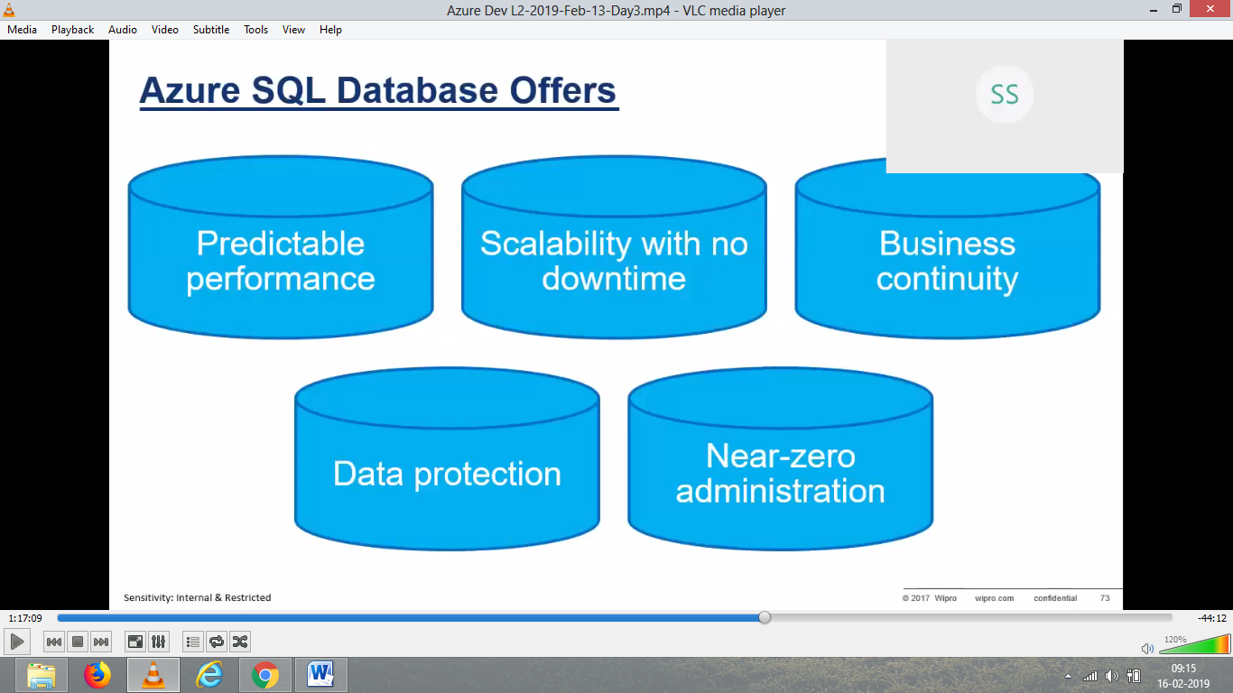

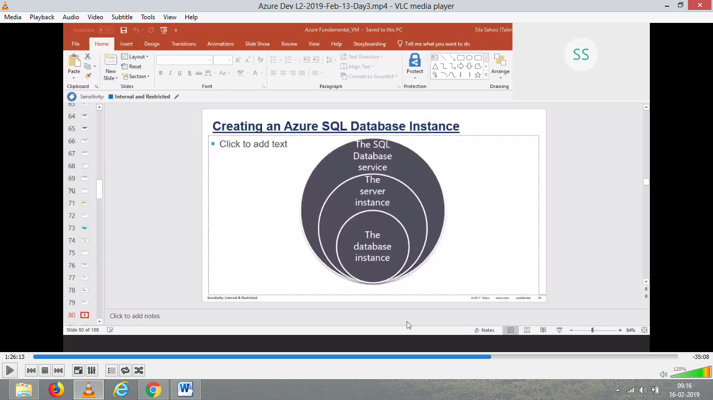

First have to crate Azure SQL database

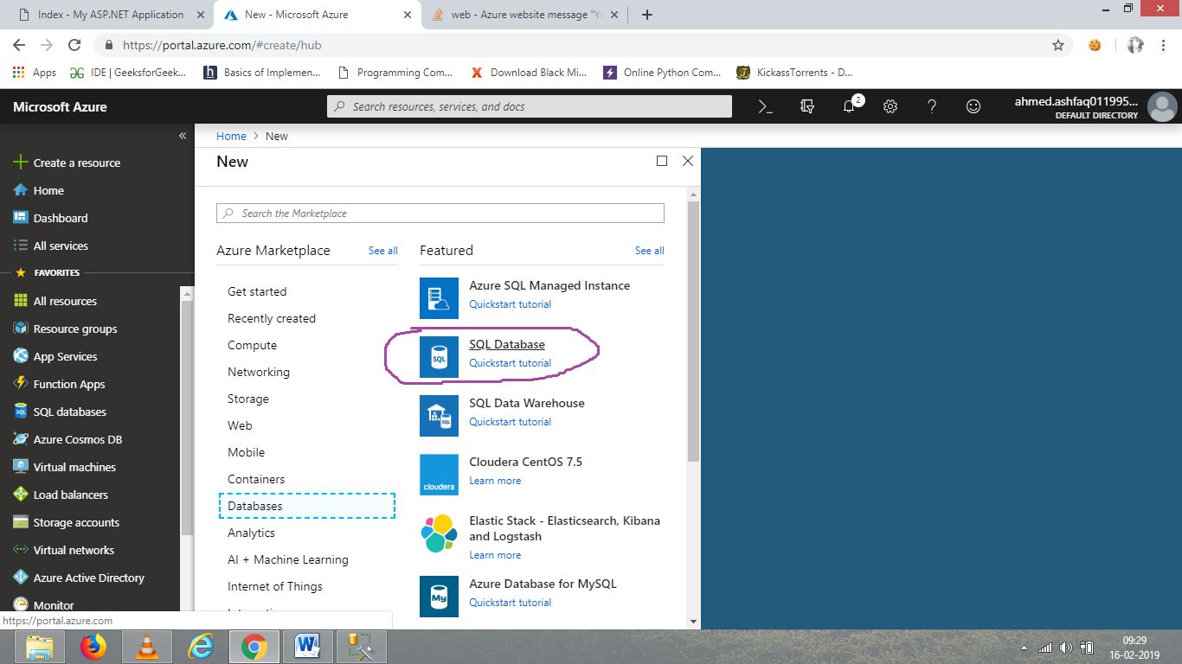

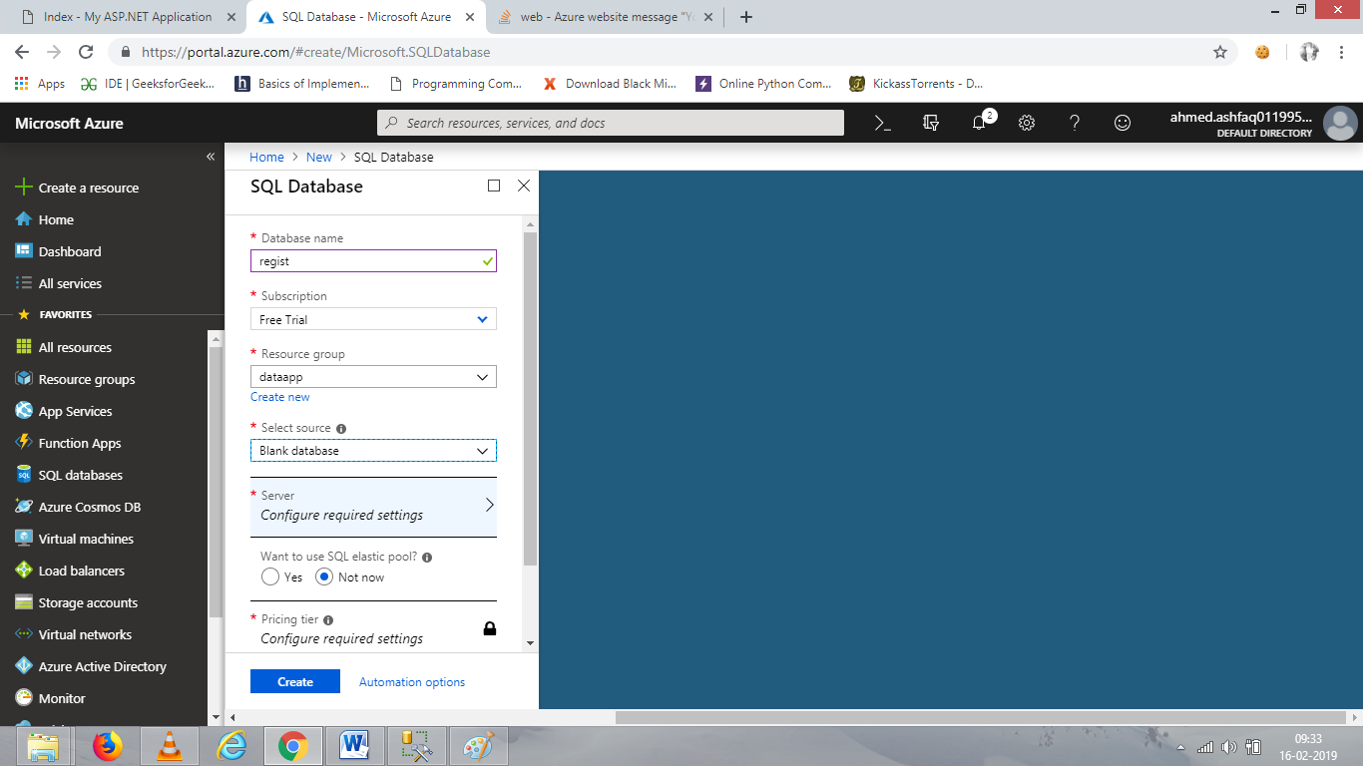

After filling name and group, create a server.

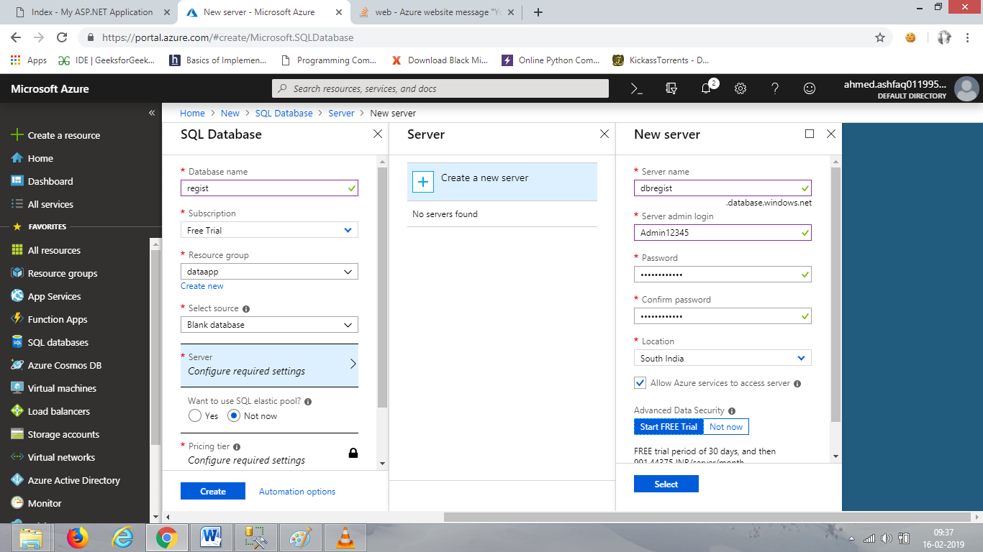

Select the location which is available that time and after giving name, username and password. Confirm it.

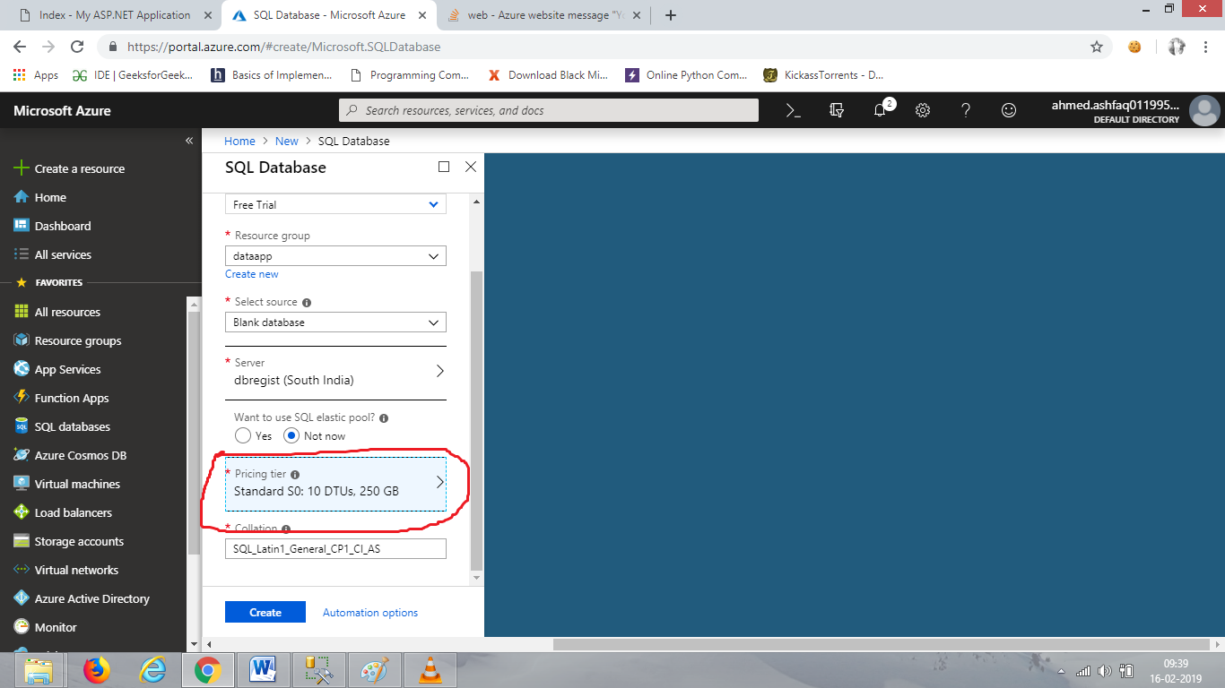

Select the pricing for it is important part for the application .

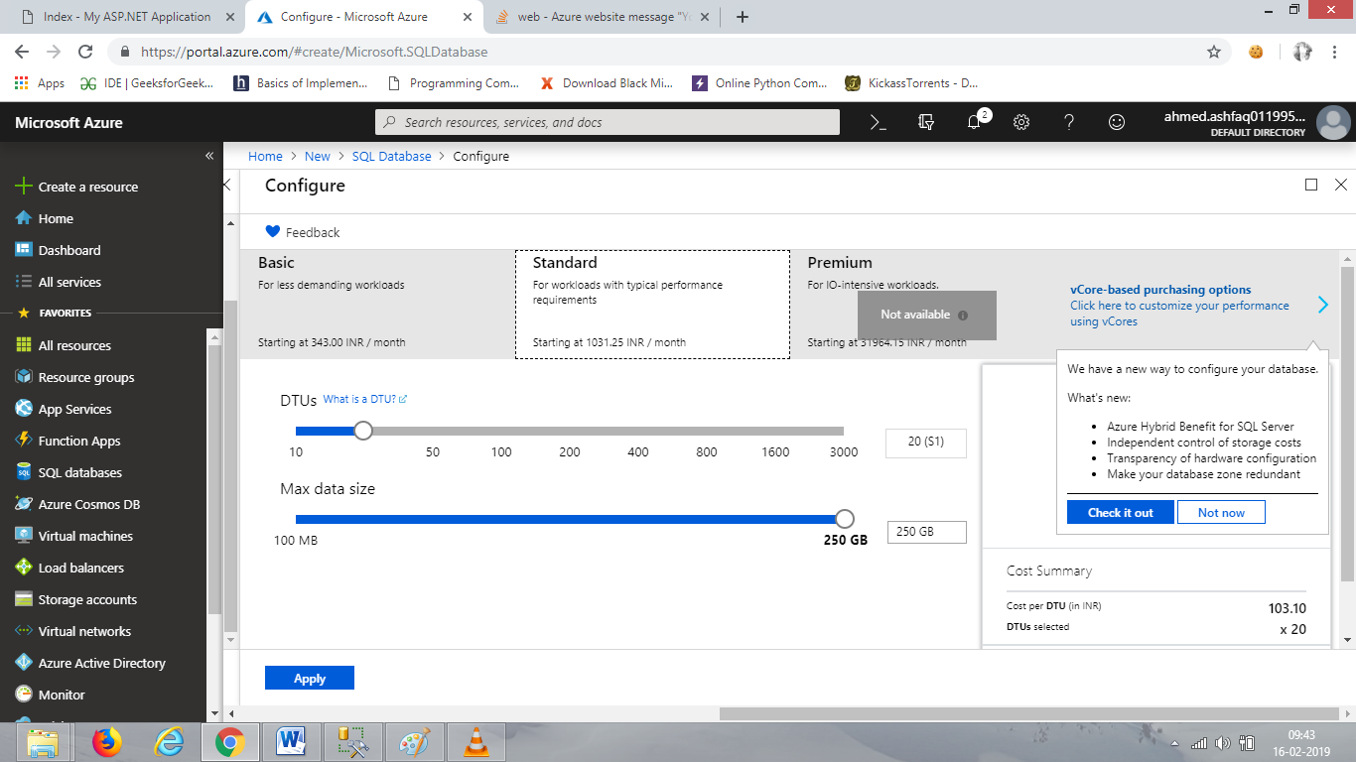

Apply and create the database.

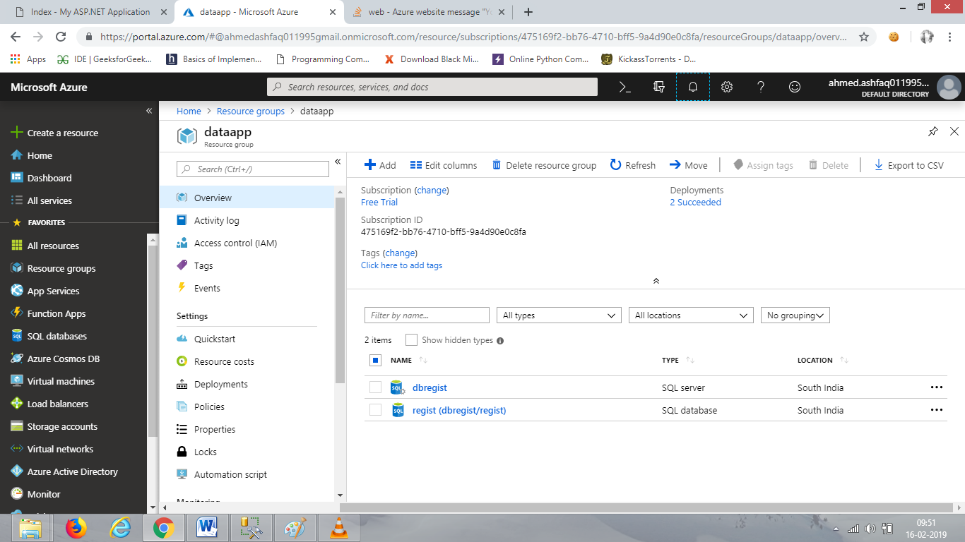

SQL server and SQL database is created. Go for database.

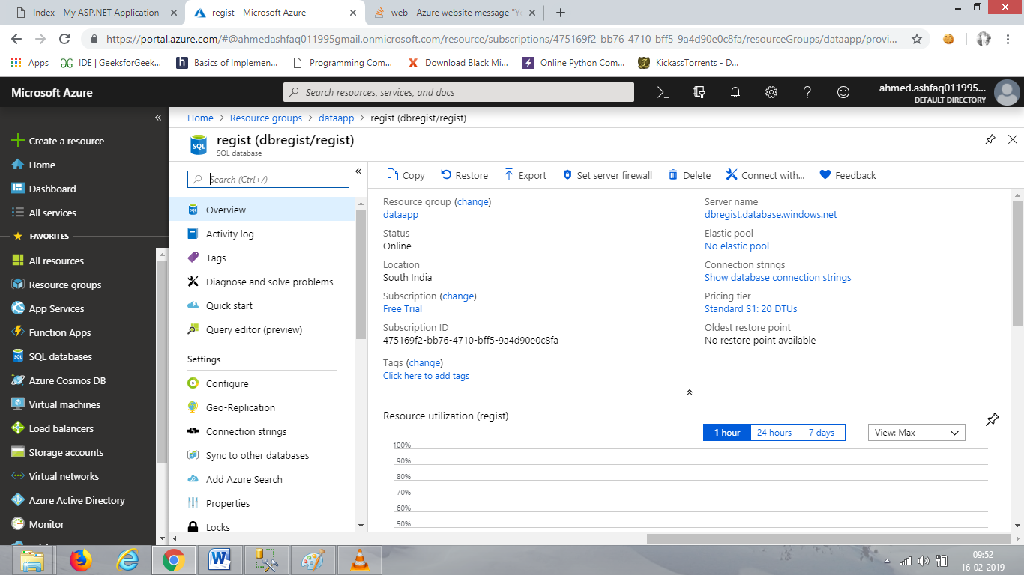

Copy the server name form here it will help us to access from SQL server management.

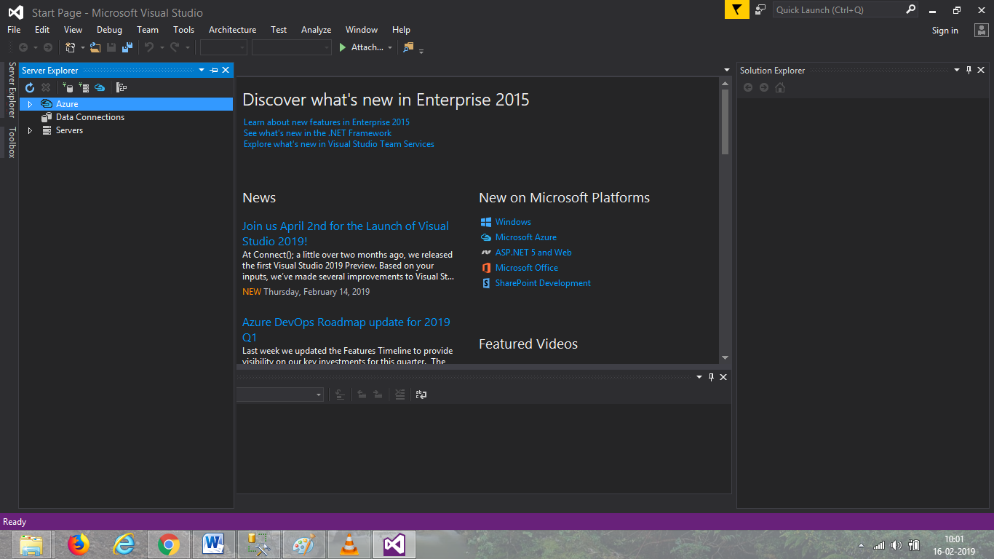

Open visual studio and go to server explorer then connect to Azure sever.

Open SQL server management and enter your azure server name and enter login credentials.

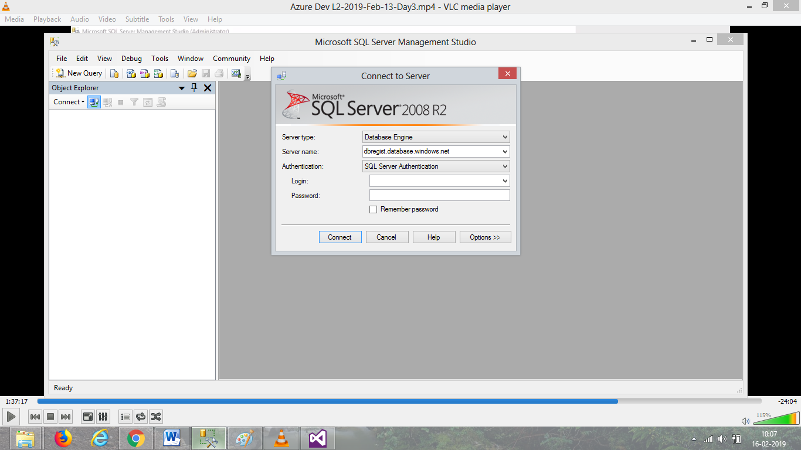

A problem/error will rise for every connection, until it is validate/allow from server.

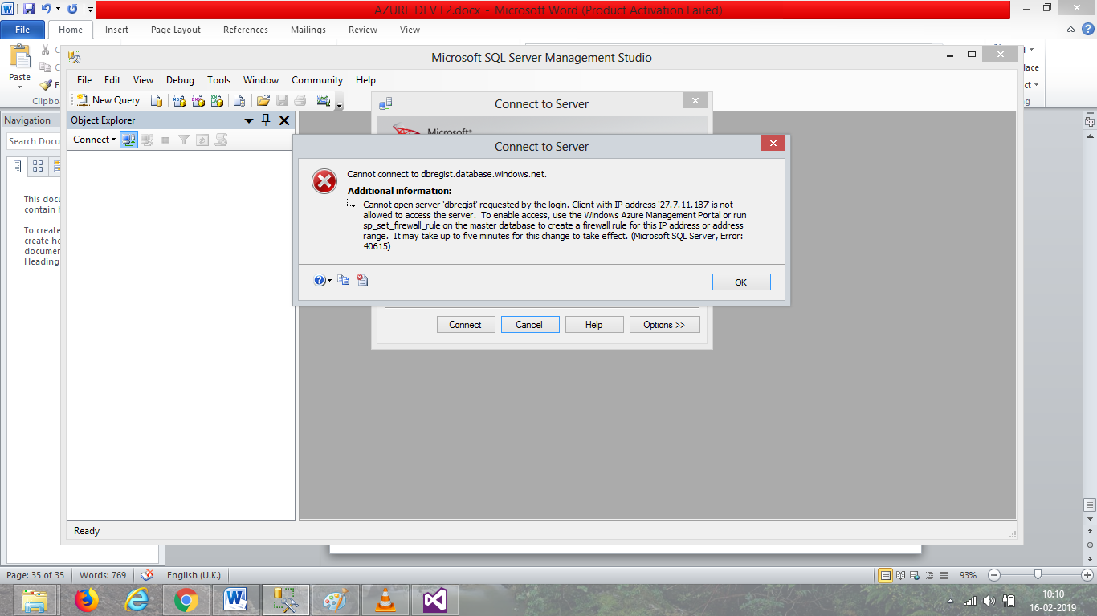

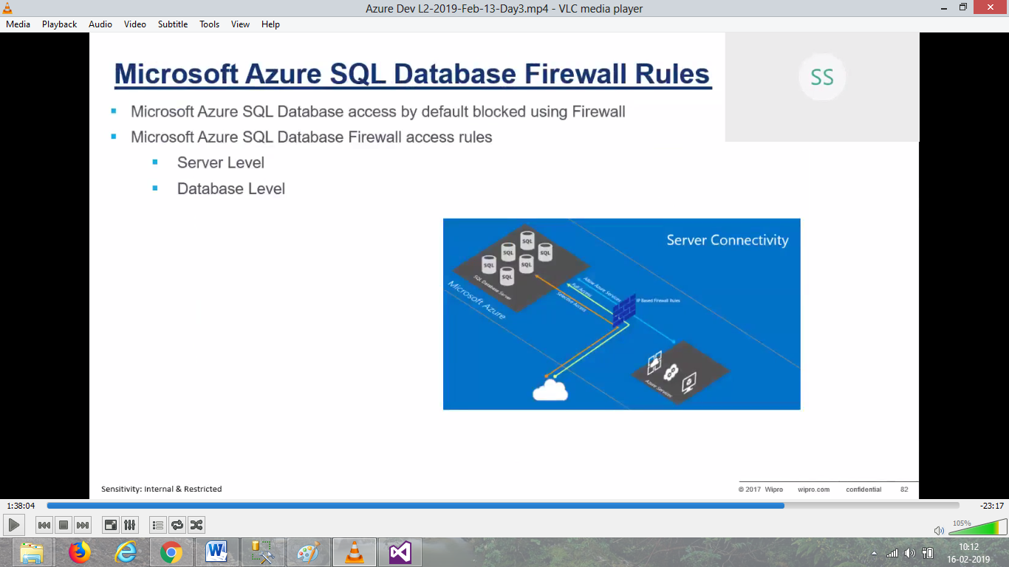

It prevents anybody to access data from azure SQL database.

So go to SQL server to allow the SQL database management.

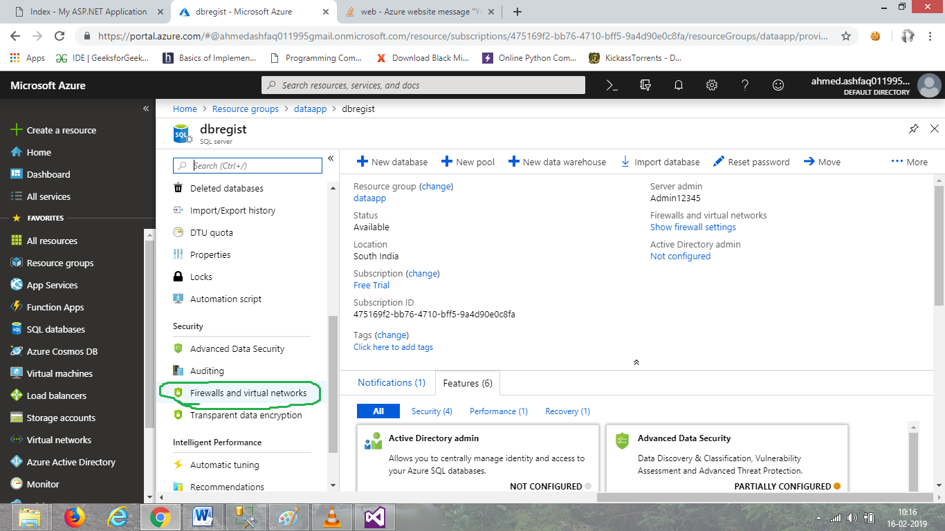

Open Azure SQL server and firewalls setting.

Add the IP address to allow that address.

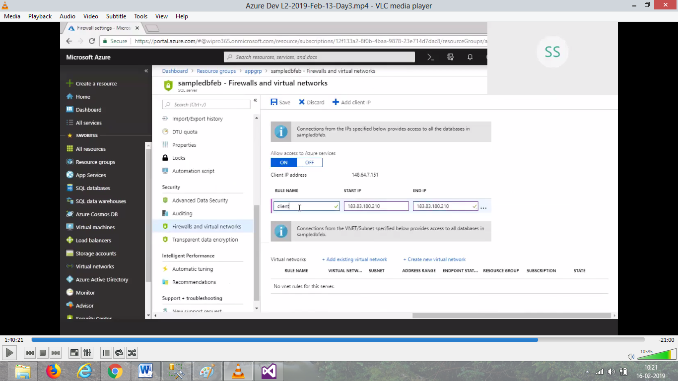

Save it after adding.

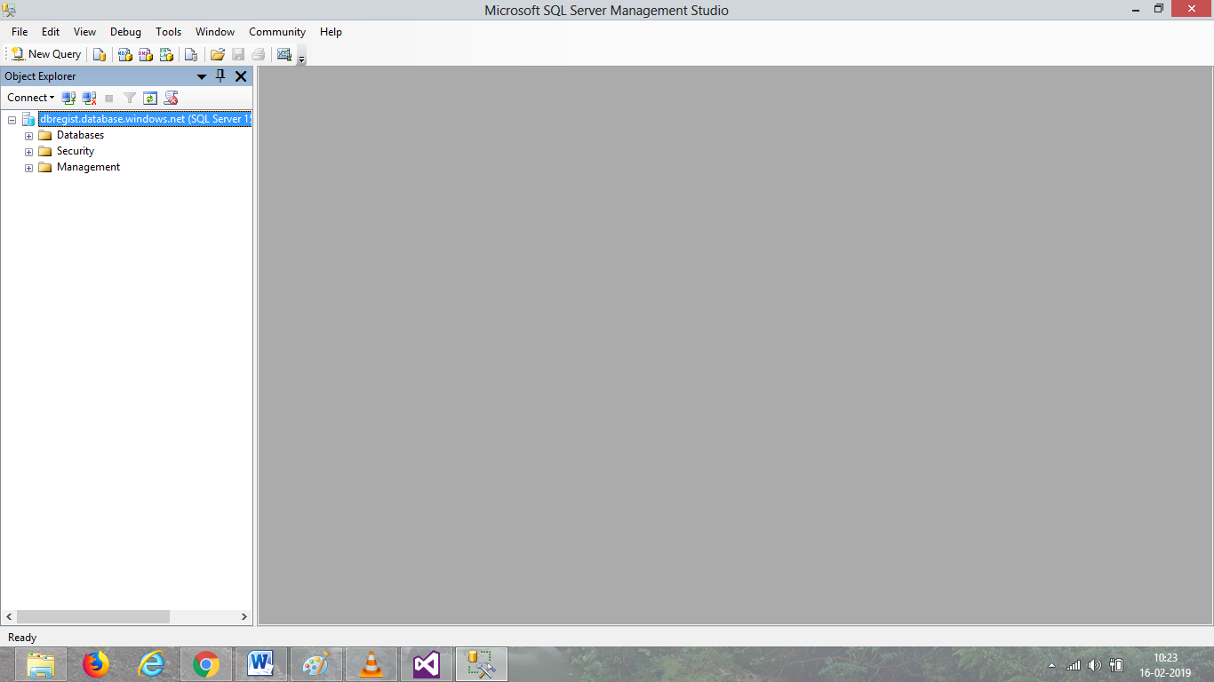

Now SQL management is connected to the azure SQL database and work can be done here normally.

Add new table in database.

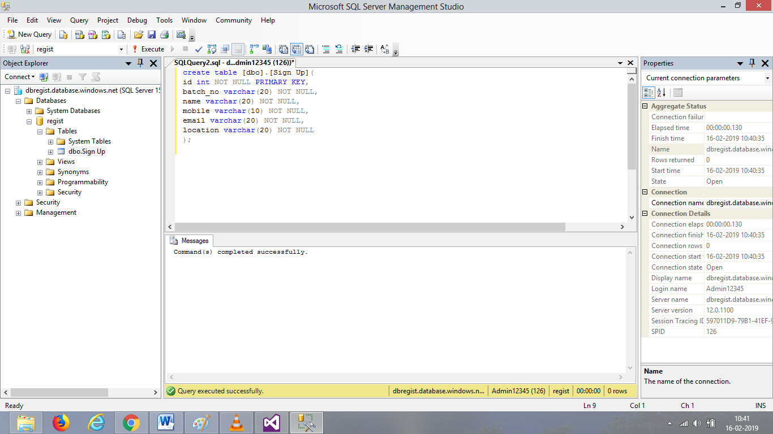

Insert some values in the table.

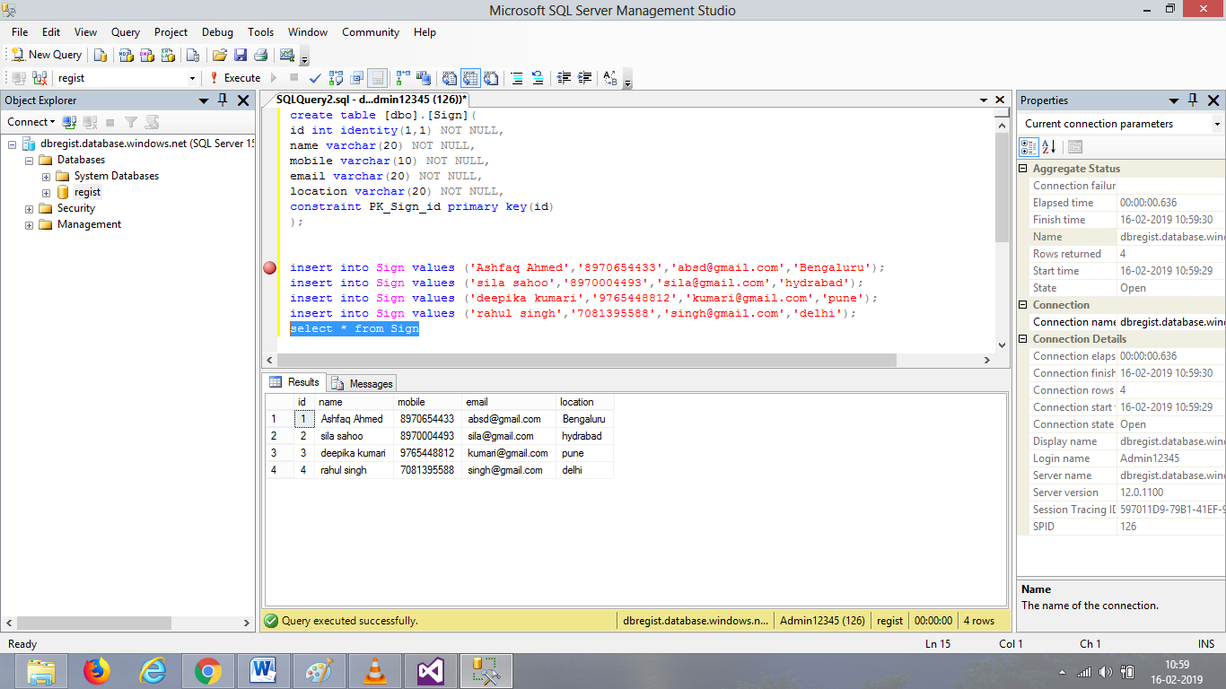

The creation of table is done, now the application in visual studio.

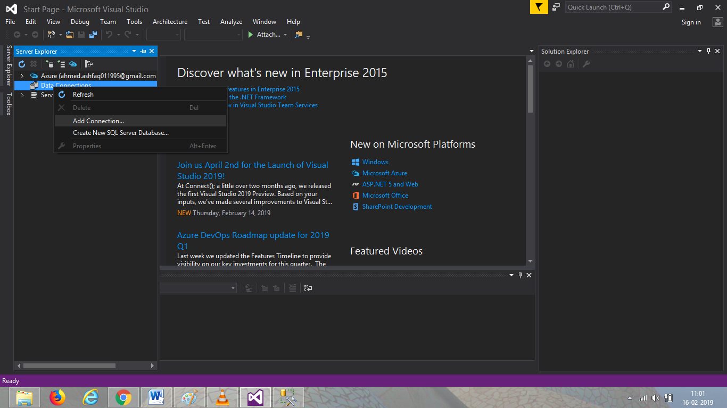

Connect the server to the visual studio.

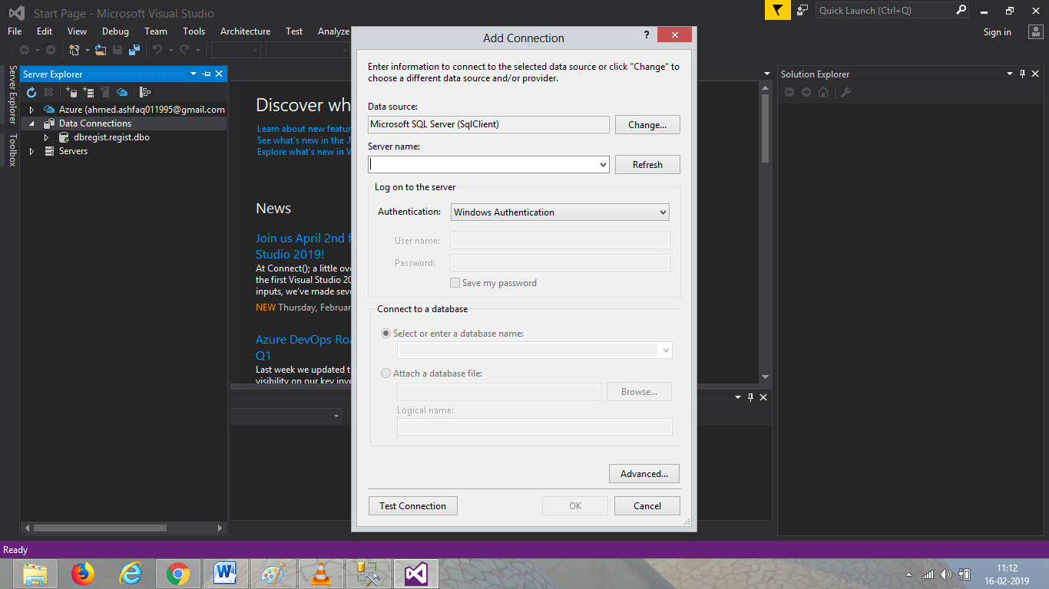

After connection establishes, create the web application.

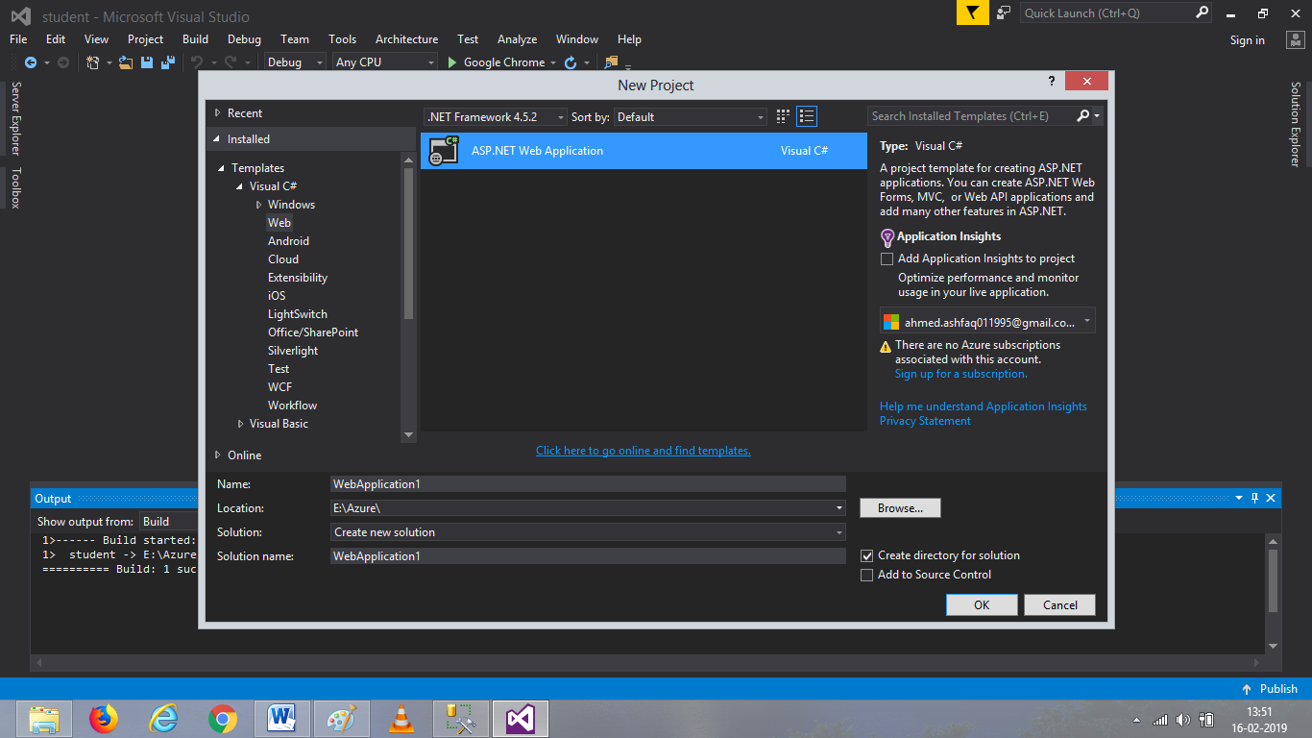

Take an empty mvc /MVC.

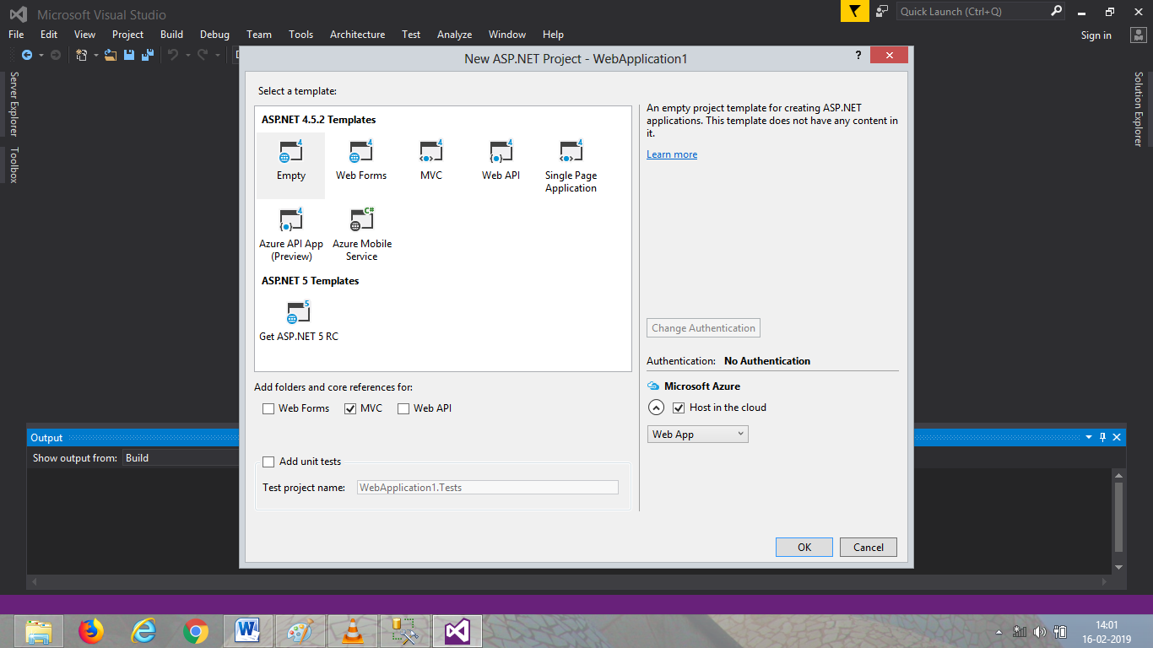

Add model first, because we have database.

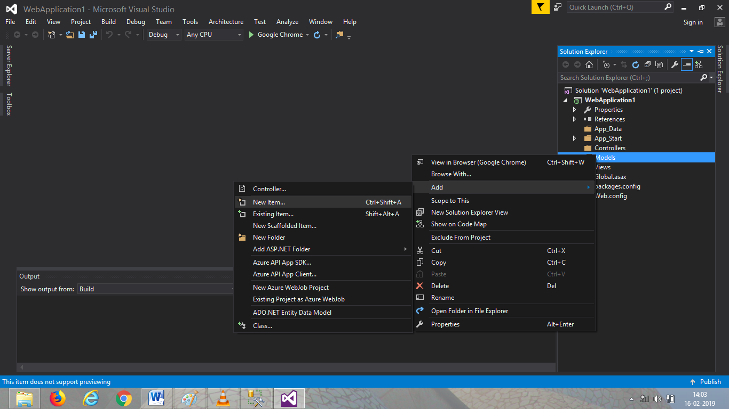

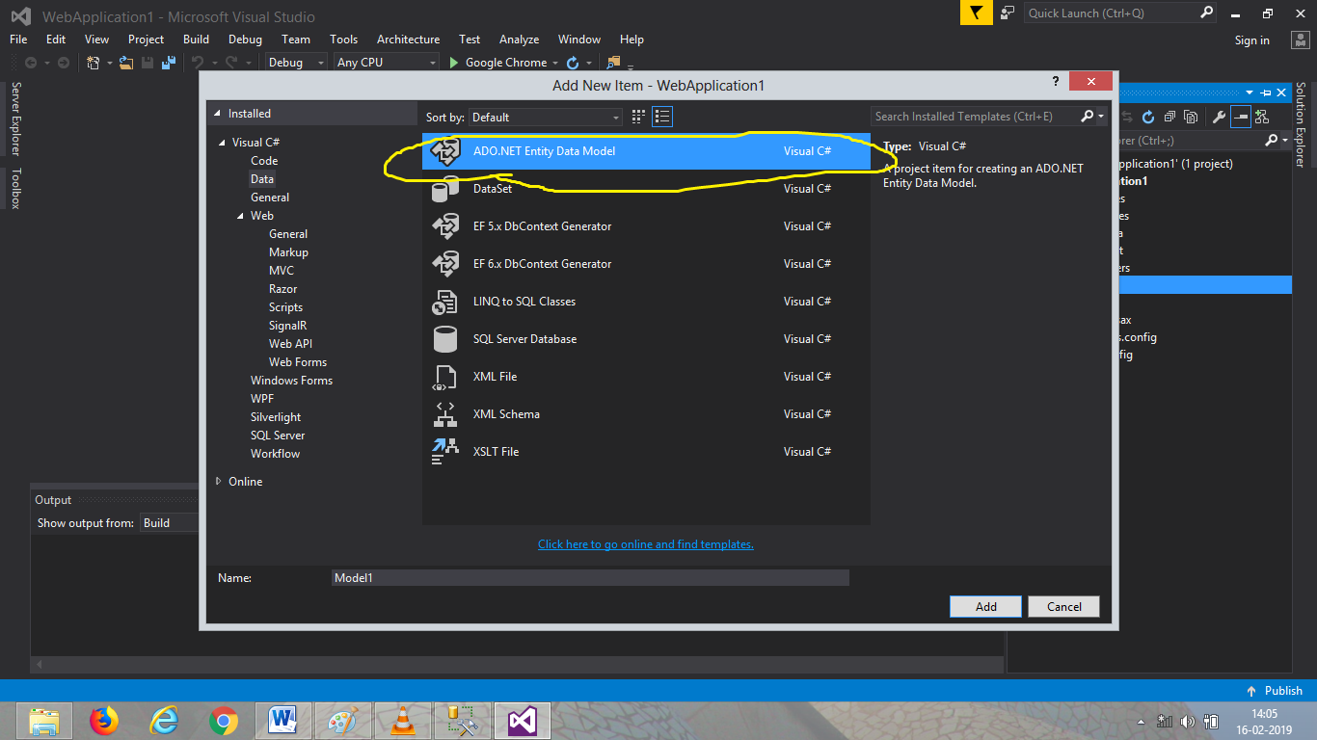

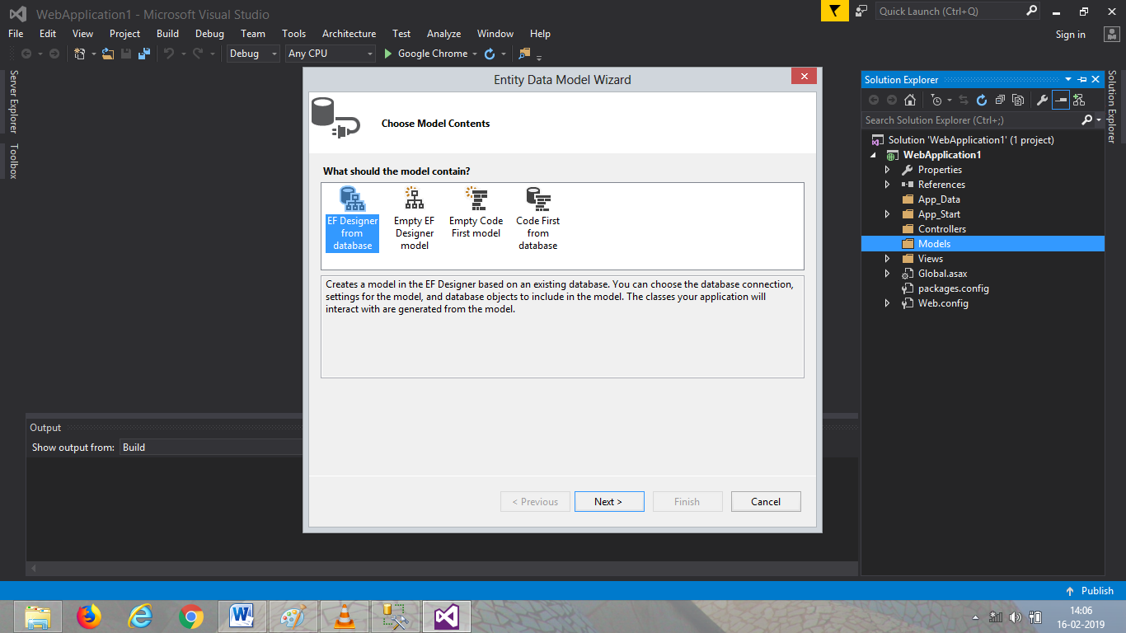

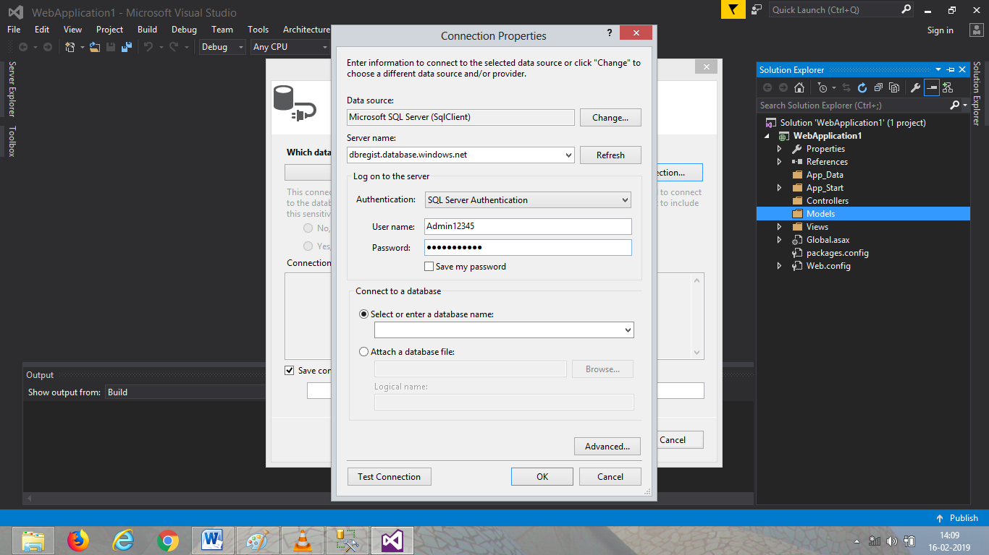

Add server name from azure server and give username and password.

Select the database and click next. Select table and finish model.

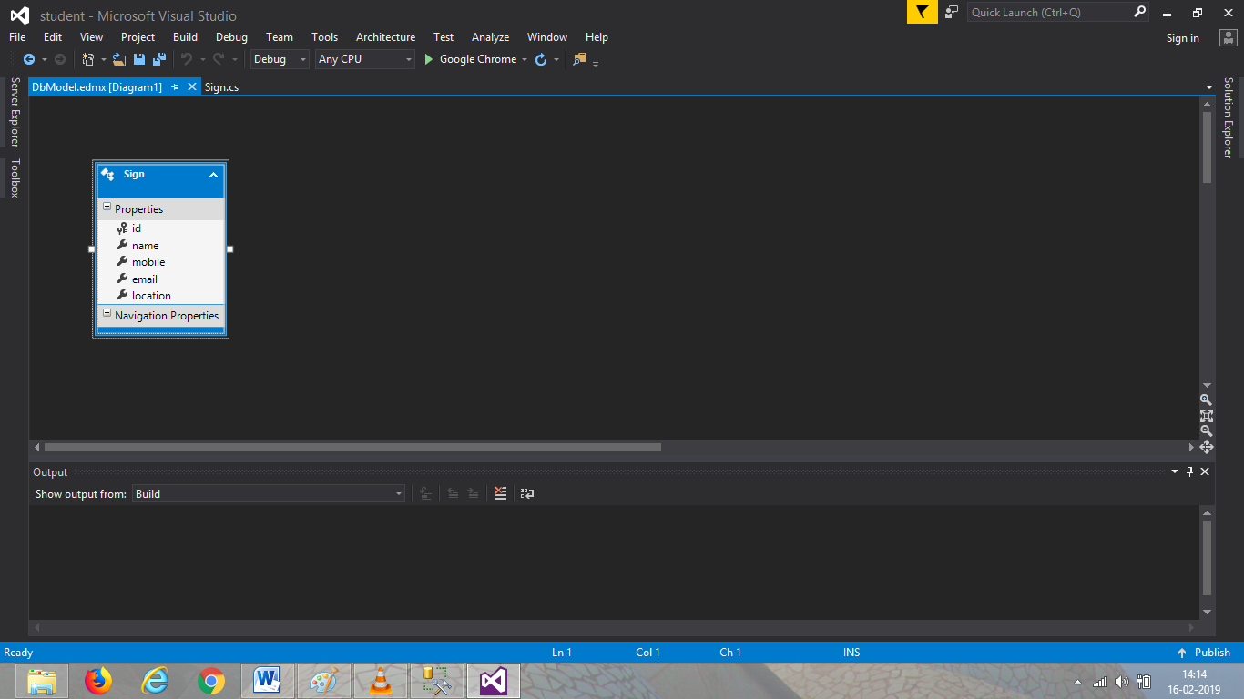

There will be .cs file for the table.

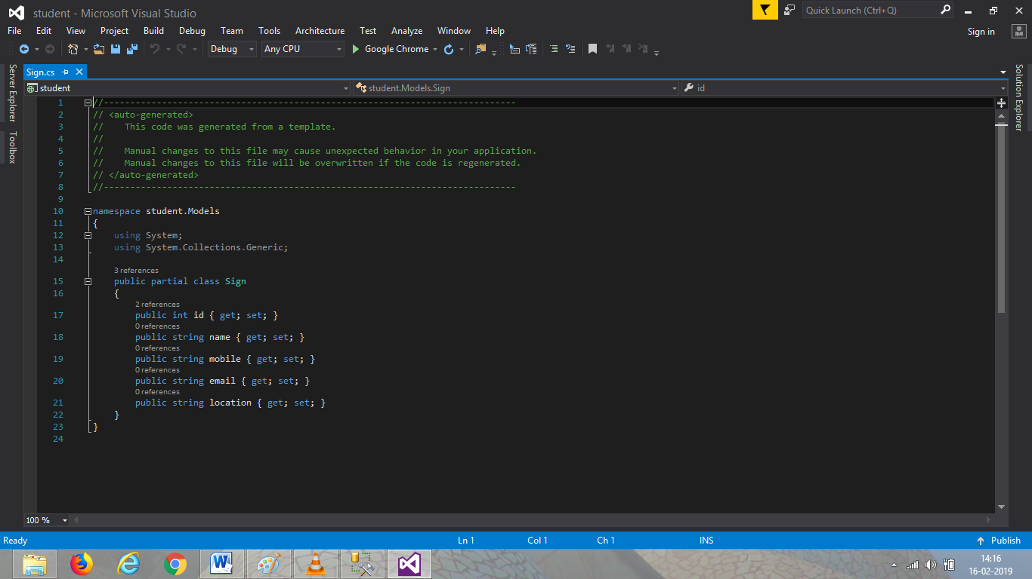

Add controller for the model.

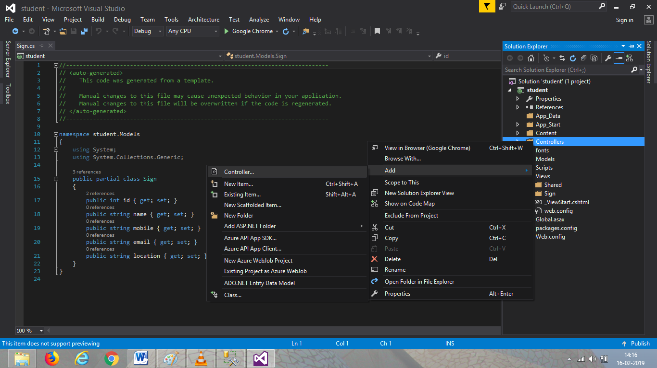

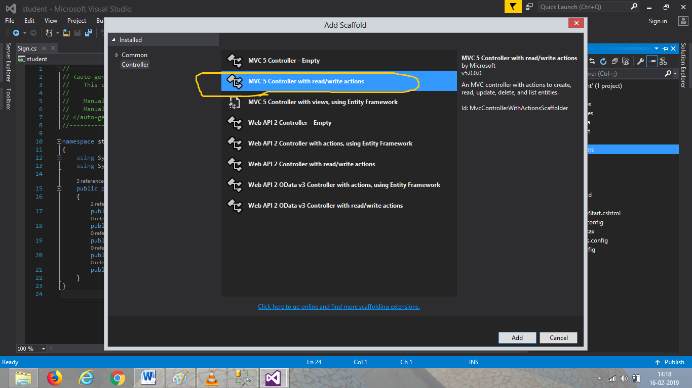

Give a name to controller.

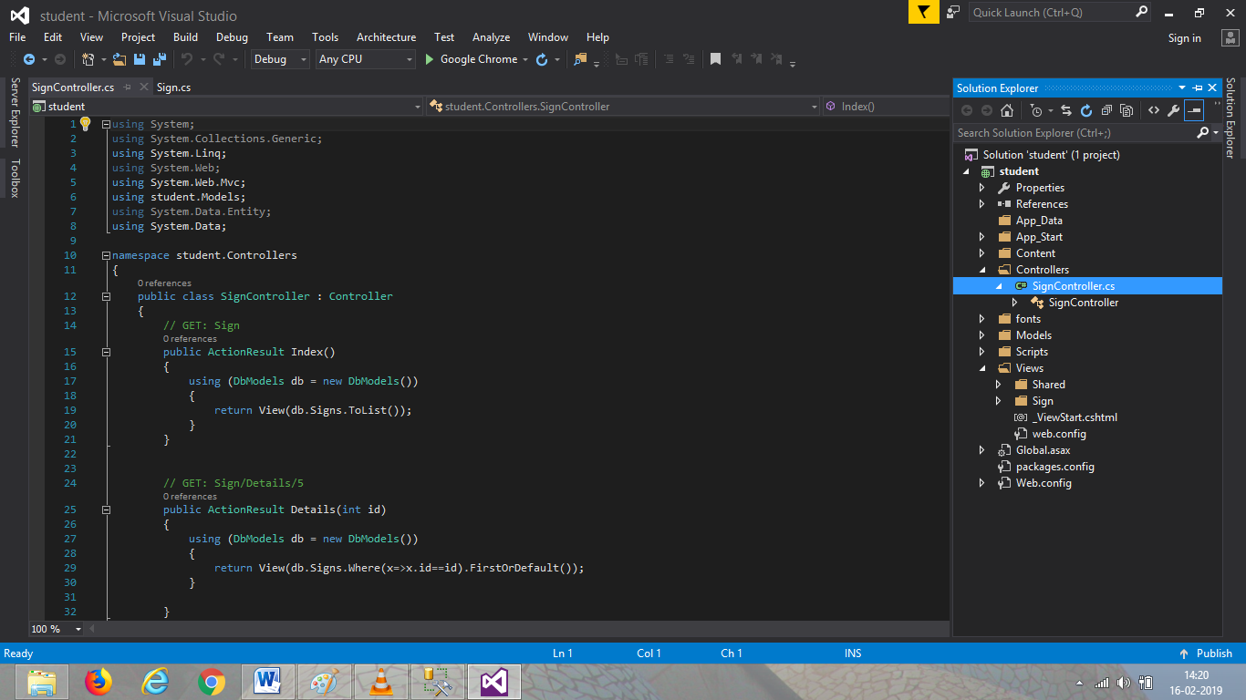

Create view for every account action(edit,index,details)

After creating view run as local to check it its working fine.

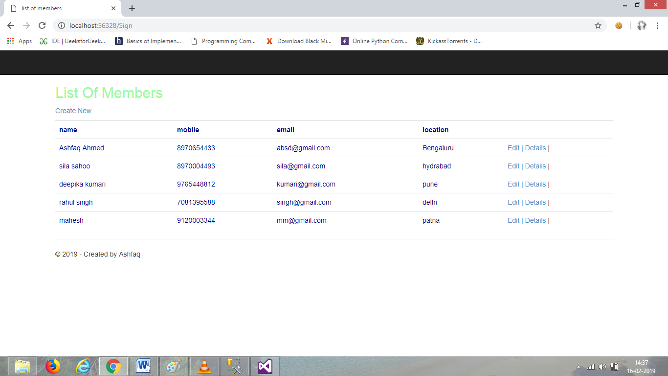

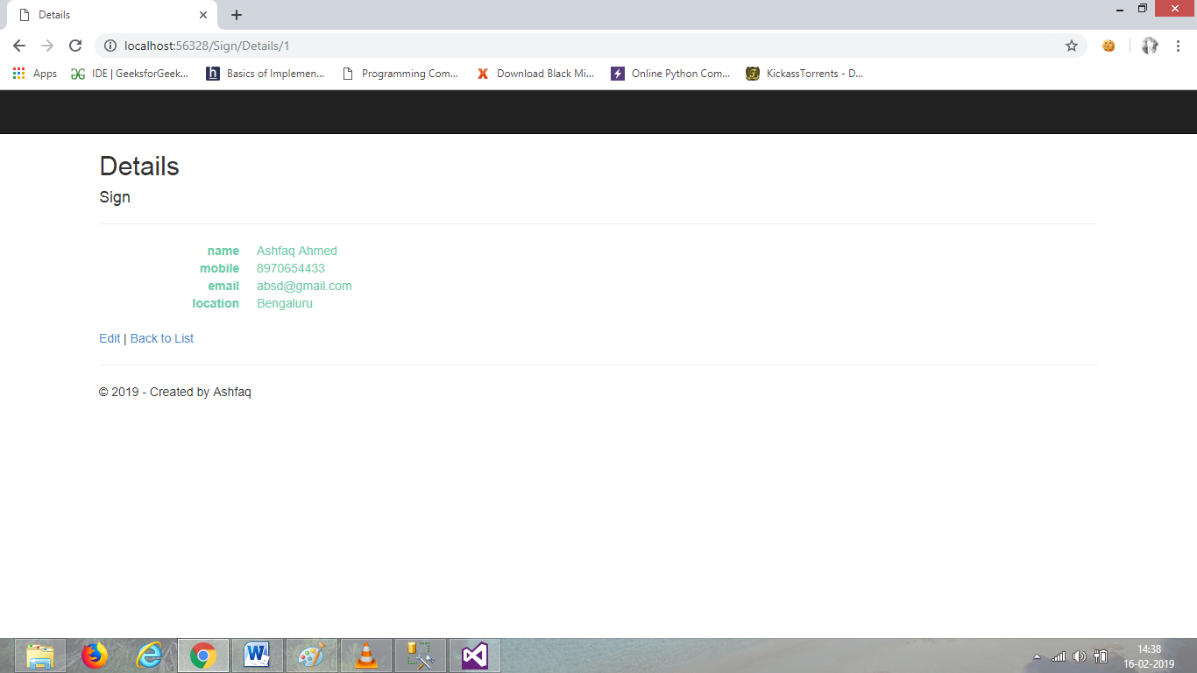

Now it’s ready to be published.

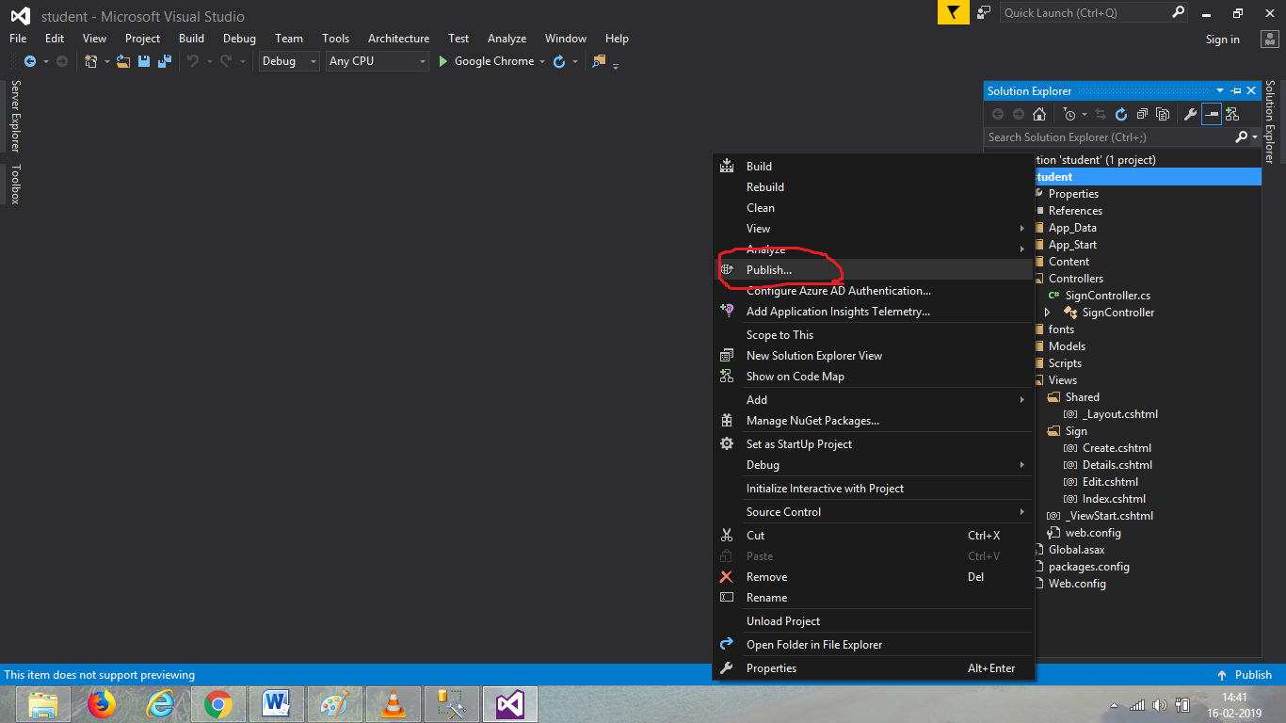

Publish using import method

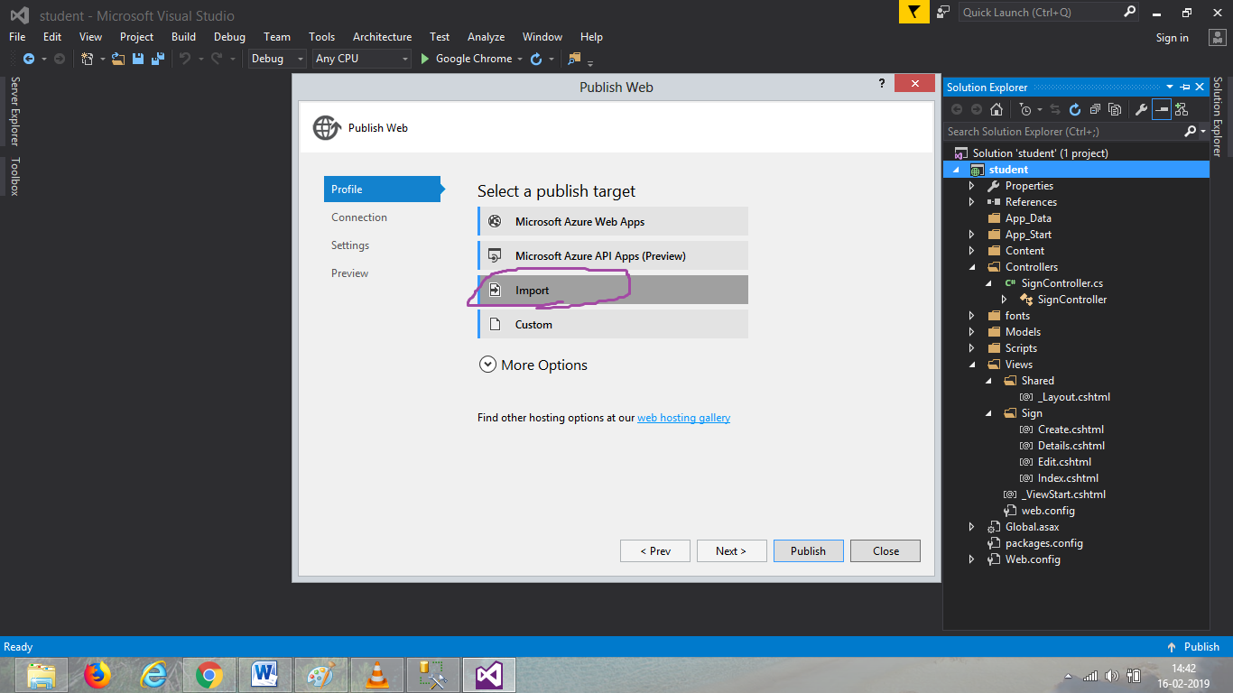

Download the import file from azure server.

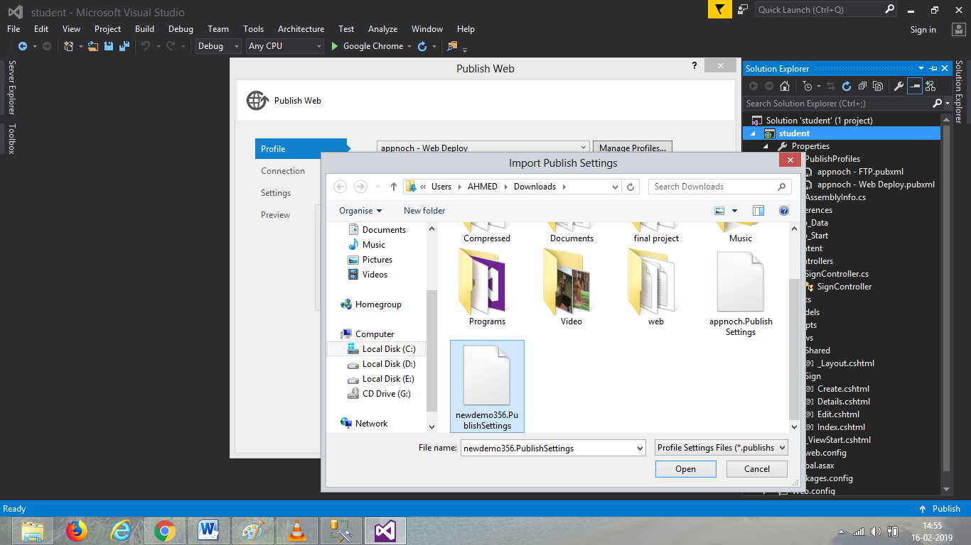

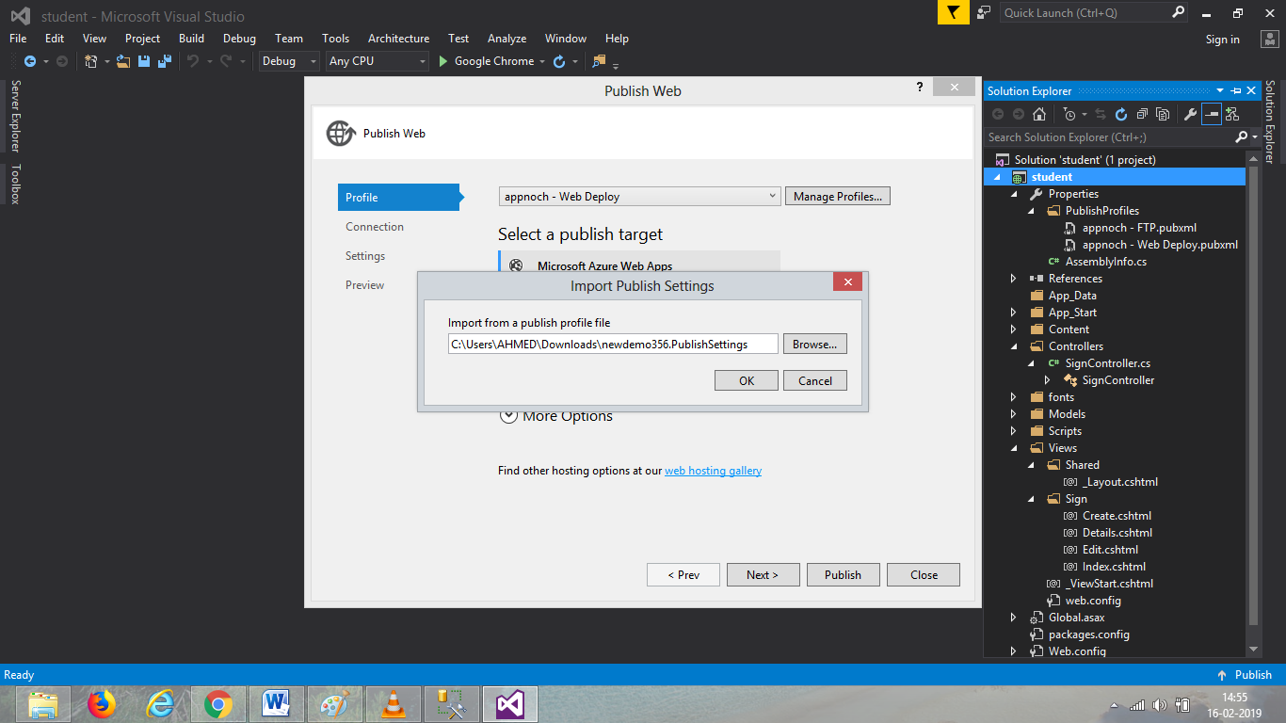

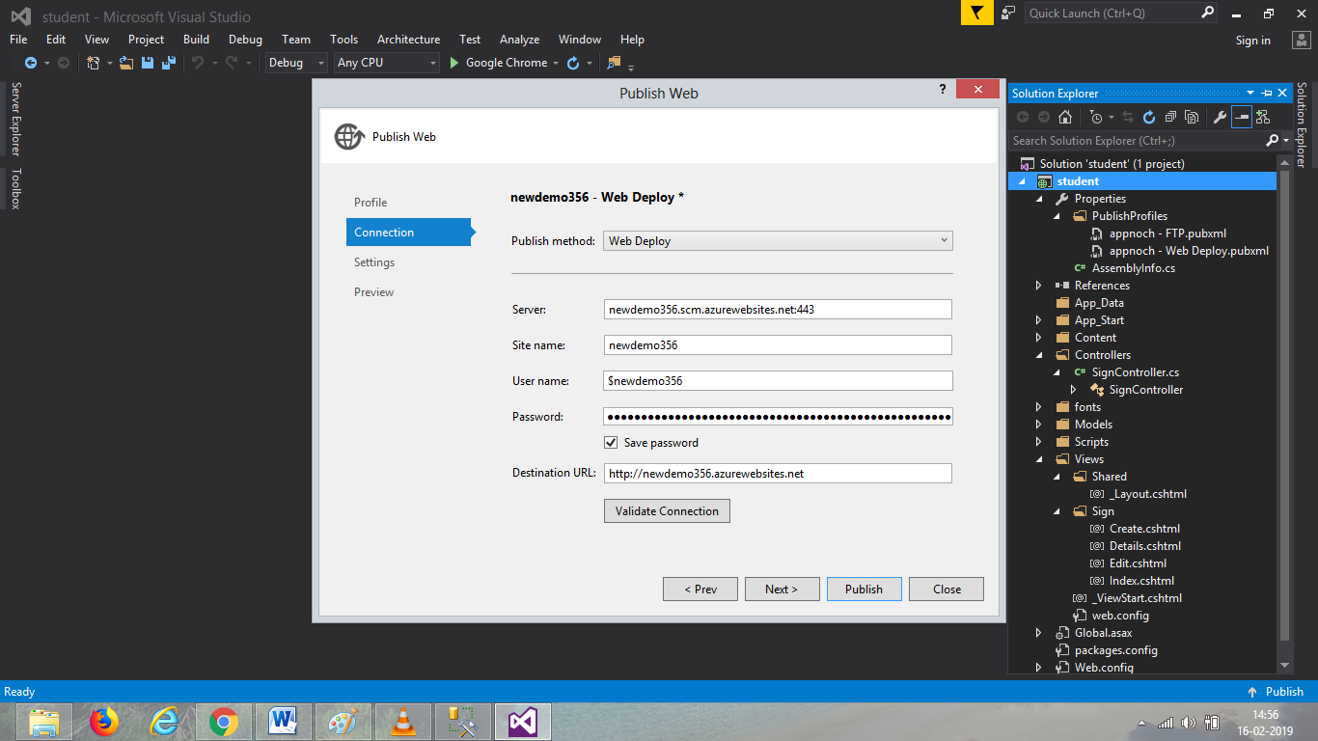

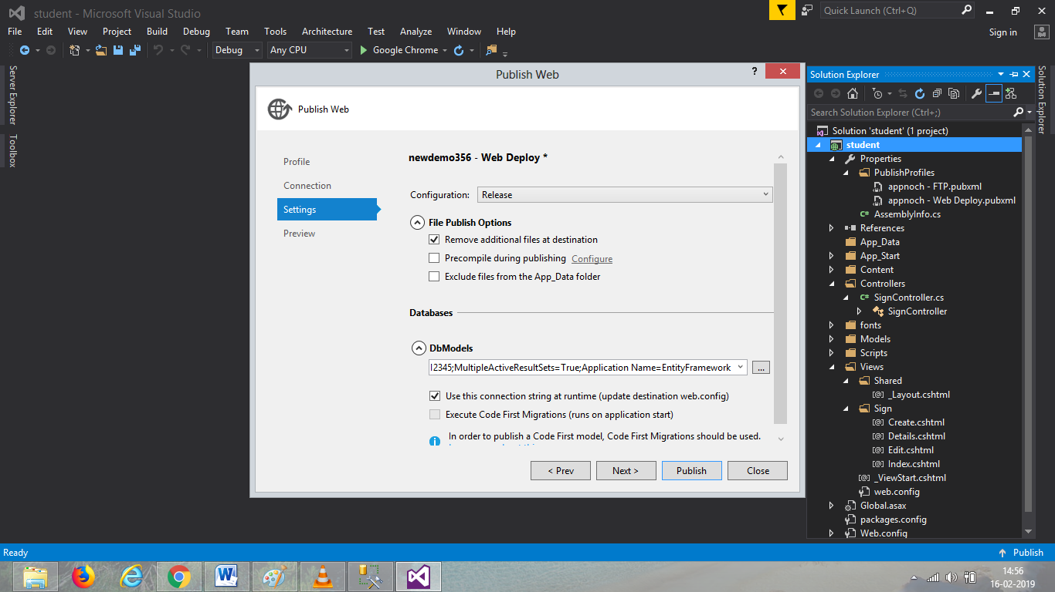

Publish now and all is done, website will be available in internet.

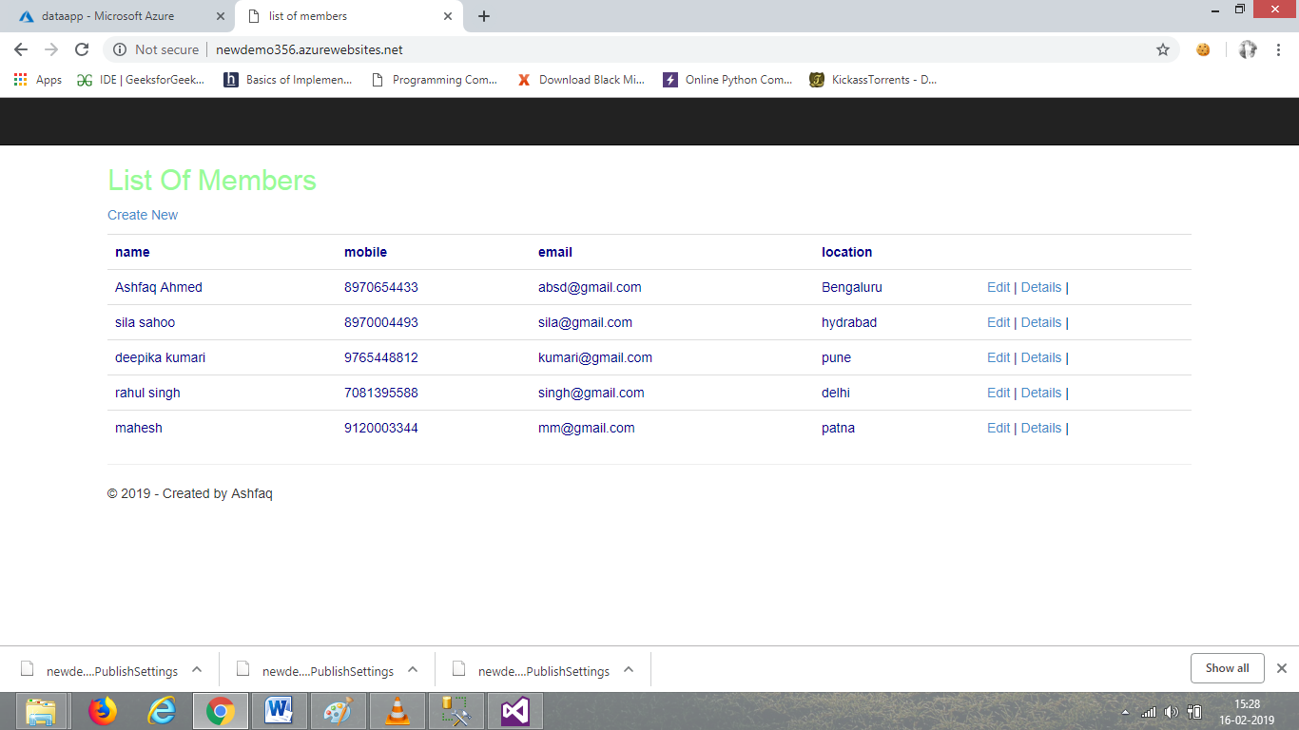

VISIT:-> http://newdemo356.azurewebsites.net